Global Migration:

A study on the factors influencing the decision to migrate and the functional outcomes from migrant seekers.

Authors:

Brandy Bergmann, Kim Duong, Danial Faisal, Harwinder Kaur,

Hitesh Kumar Khatri, Wouter Moedt, Ranga Reddy

*05/01/2019*

Abstract:

Immigration is a global issue. In the United States, the tug between border control and increasing immigration halted the approval of the 2019 national budget. In Europe, the individual countries within the European Union are disputing over the volume of immigrants as some countries consume the larger portion of immigrants while others close their borders. National and international immigration policy affects natural migration of individuals between countries but also the forced migration as refugees and asylum seekers. The purpose of this paper is to review the factors that impact the decision to migrate and the outcome security that individuals are seeking by migrating.

Key Words

Immigration, Migration, Immigration Policy, Refugees, Asylum, Economic Security, Political Security, Environmental Security

Contents

[1.0 Introduction and Review of Literature 3](bookmark://_Toc7632099#_Toc7632099)

[1.1 Definitions on the types of Immigration 3](bookmark://_Toc7632100#_Toc7632100)

[1.2 Immigration Policy—General Policy 3](bookmark://_Toc7632101#_Toc7632101)

[1.2.1 European Policy (historical & today) 4](bookmark://_Toc7632102#_Toc7632102)

[1.2.2 American Policy (historical & today) 5](bookmark://_Toc7632103#_Toc7632103)

[1.2.3 Asylum seeking policy (historical & today) 6](bookmark://_Toc7632104#_Toc7632104)

[1.2.4 European Asylum-Seeking Policy 8](bookmark://_Toc7632105#_Toc7632105)

[1.3 Factors of Immigration 9](bookmark://_Toc7632106#_Toc7632106)

[1.3.1 Economic Factors 9](bookmark://_Toc7632107#_Toc7632107)

[1.3.2 Environment Factors 12](bookmark://_Toc7632108#_Toc7632108)

[2. Theory and Model Development 16](bookmark://_Toc7632109#_Toc7632109)

[2.1 Hypotheses and research questions 16](bookmark://_Toc7632110#_Toc7632110)

[3. Analysis & Methodology 18](bookmark://_Toc7632111#_Toc7632111)

[3.1 Flow of International Migration 18](bookmark://_Toc7632112#_Toc7632112)

[3.1.1 European Migration 21](bookmark://_Toc7632113#_Toc7632113)

[3.1.2 United States Immigration 23](bookmark://_Toc7632114#_Toc7632114)

[3.1.3 Volume of Illegal Immigration 24](bookmark://_Toc7632115#_Toc7632115)

[3.2.0 Factors of Immigration 25](bookmark://_Toc7632116#_Toc7632116)

[3.2.1 Economic Factors 25](bookmark://_Toc7632117#_Toc7632117)

[3.2.2 Social Factors 30](bookmark://_Toc7632118#_Toc7632118)

[3.2.3 Environmental Factors 43](bookmark://_Toc7632119#_Toc7632119)

[3.2.4 Independent Factors 46](bookmark://_Toc7632120#_Toc7632120)

[4. Discussion 47](bookmark://_Toc7632121#_Toc7632121)

[4.1 Findings/recommendations 47](bookmark://_Toc7632122#_Toc7632122)

[4.2 Data gaps 47](bookmark://_Toc7632123#_Toc7632123)

[4.3 Future research 47](bookmark://_Toc7632124#_Toc7632124)

[4.4 Conclusion 48](bookmark://_Toc7632125#_Toc7632125)

[5. References 49](bookmark://_Toc7632126#_Toc7632126)

## 1.0 Introduction and Review of Literature

Immigration is a complex. Individuals migrate for a variety of reasons. The purpose of this research is to understand the primary factors for migration affecting the decision to migrate and the outcome security that individuals are seeking through migration. In the next section, immigration is defined and the policies affecting international immigration.

## 1.1 Definitions on the types of Immigration

Immigration is the process of moving from one country to another to live permanently. Migration, a broader term, is the process of moving with the intention of settling permanently or temporarily [14]. Migration delineates into several categories, internal and international and then forced or voluntary. Internal migration occurs when one individual (or family), moves to another area within a country’s borders. International migration is the movement from one country to another. Furthermore, migration may be voluntary or forced. Voluntary migration occurs when an individual (family) seeks better economic opportunities and housing [14]. Forced migration occurs when individuals (families) are expelled due to war or political conflict [14]. Often, these migrants are transported as slaves or prisoners [14]. However, refugees fleeing war, famine and natural disasters are intermediary between voluntary and forced migration.

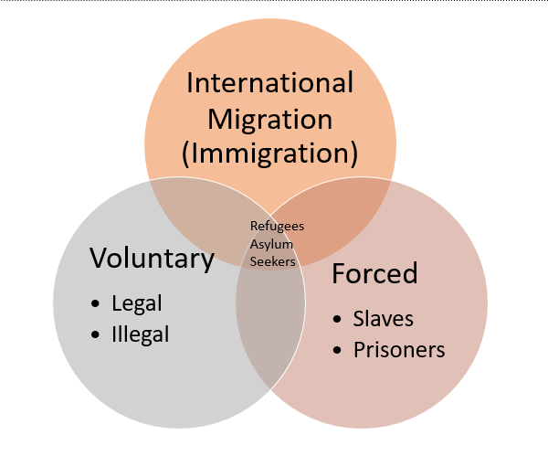

Figure 1: Types of Immigration

.

## 1.2 Immigration Policy—General Policy

Immigration policy consists of legislative and administrative policies, court decisions and regulations that shape a country’s immigration system [16]. Immigration policy is the architecture that affects the demographics, culture, economy, and politics of a country. Immigration policy has two primary objectives, 1) immigration control/regulation and 2) Immigration policy.

First, Immigration control is the rules and processes that determine the admission of foreign citizens into a country. Immigration control focuses on the selection of permanent immigrants, temporary migrant workers and refugees and restricts illegal immigration and the ethnic origin of the migrants. It covers the “who”, “what type” of migrant and “from where does he/she come” questions.

On the other hand, Immigration policy defines the conditions, or the “when” and “why”, provided for resident immigrants. The immigrant policies refer to the working/housing conditions, welfare provisions and educational opportunities [16]. An interdisciplinary subject spans across political science/politics theories, international relations, sociology and psychology. An article by Meyer [16] delineates the strengths and weakness of six approaches to immigration policy including Marxism (and neo-Marxism), realism, liberalism, “national identity”, domestic policies (partisan and interest group politics), and institutionalism [16]. After evaluating each of these approaches in detail, Meyer [16] found a collaborative approach to using these ideals. For example, policies use realism to understand refugee policy and global power relationships. Other policies use Marxism to understand migrant workers and illegal immigration, neoliberalism on EU policies (and refugee crises), and institutionalism on policies regarding refugees and migrant workers.

### 1.2.1 European Policy (historical & today)

In 2013, Finotelli and Sciortino discuss the current state of European visa policies and immigration control. From the 1980s onwards, European governments have attempted to enforce a restrictive immigration and asylum strategy, because of illegal migration. This has led to Europe being referred to as ‘Fortress Europe’ by various researchers. Nevertheless, in 2013 it was estimated that European countries hosted up to 3.8 million irregular immigrants (immigrants who did not possess the required authorization). In addition, it was estimated that several million irregular immigrants acquired legal status through special programs, after they had illegally entered the European Union. At the same time, it was reported that almost three out of four immigrants in the Italian amnesty program had entered the country legally.

As the European Union consists of many different countries, not only the number of incoming immigrants varies, but so does that attitude towards immigrants. In 2008, Meuleman and Reeskens divided the member states of the EU into three classes, based on how tolerant the population of each country is towards immigration. The first class included the 9 most tolerant countries (*U.K., Portugal, Spain, Italy, the Netherlands, Belgium, Norway, Sweden* and *Finland*), followed by the second class (*France, Germany, Switzerland, Luxembourg* and *Ireland*) and the third class (*Greece, Denmark, Austria, Czech Republic, Hungary, Slovakia, Poland, Lithuania, Latvia* and *Estonia*). It should be noted that some countries have a longer history of immigration than others do, which could explain the differences. Moreover, it shows that although the EU tries to harmonize immigration policies, populations of different countries have different opinions.

However, there is also another aspect that has an effect on immigration in Europe. The Schengen Agreement was signed by European leaders in 1985, and allows citizens of 26 member states to enter, live and even work in countries within the Schengen Area without any restrictions (Davis & Gift, 2014). This has created a unified European market, in which border control could be eliminated and both goods and people can be moved freely. Altogether, this unified market has reduced bureaucracy and increased collaboration between member states. However, allowing goods and people to move around member states can also have an effect on immigration. For example, a visitor on a visa entering Spain could continue to other member states, even though an additional visa would have officially been required to do so. At the same time, when Greece became a member state it did not lead to a migration of its lower-class population to wealthier member states (Guild & Bigo, 2017).

### 1.2.2 American Policy (historical & today)

U.S. Immigration law is complex. The Immigration and Naturalization Act (INA) is the law governing U.S. Immigration Policy. It limits an annual limit of 675,000 permanent immigrants, with exceptions for close family members [17]. Lawful residency allows for foreign born immigrants to work lawfully and permanently within the United States. They are eligible for nearly all jobs and can remain within the United States even if unemployed.

Immigration to the United States follows four basic principles: 1) reunification of families, 2) admitting skilled laborers 3) refugee protection and 4) promoting diversity.

Family based immigration allows the admission of immediate relatives of a United States Citizen or family preferences [17]. Immediate relatives are considered spouses, unmarried minor children (under 21 years of age), and parents [17]. A limited number of visas are available for “family preferences” including adult children (married and unmarried), spouses of a legal resident. Note that under both types of admission, the prospective immigrants must meet eligibility criteria, age and financial requirements.

For employment-based immigration, visas are provided for immigrants with valuable skills to come to the United States both permanently or temporarily. Temporary employment-based visas are utilized for limited periods and there are about 20 types of temporary work visas [17]. Permanent employment visas are limited per year and divided into five categories including “extraordinary ability, professional (advanced degrees), skilled labor for non-temporary/seasonable positions, special immigrants including religious workers former U.S. government employees, and individuals investing money in job-creating enterprises that will employ at U.S. fulltime workers [17].

Per-Country ceilings limits no group of permanent immigrants from a single country can exceed 7% of the total number of people immigrating to the United States in a single year [17]. This is a limit to prevent any immigrant group from dominating immigration patterns to the U.S. [17].

Finally, refugees are admitted based on their inability to return home because of “founded fear of prosecution” [17]. Prosecution is defined by particular social group, political view, religion, national origin. Refugees apply to the United States from a transition country. Admission is dependent on degree of risk, membership to groups of particular interest to the United States, and whether they have family members currently in the United States [17].

Asylum is similar to refugee status however that the individual is already in the United States and are seeking protection for the same grounds that other refugees may have. They apply at port of entry seeking admission or within the year of arriving in the United States. At this time, no limit is set to the number of individuals granted asylum in a given year [17]. Refugees and Asylum policies are discussed in further detail in the next section as this is pertaining to just the United States.

The Diversity Visa Program enacted by the Immigration Act of 1990 is dedicated for immigrants from countries with low rates of immigration to the United States [17]. To be eligible, an immigrant must have a high-school education and within the last five years, dedicated two years as a professional or professional in training. Spouses and minor unmarried children may also enter as dependents [17]. A random computer-generated algorithm chooses individuals evenly distributed among six geographic regions with low rates of immigration from countries with less than 50,000 immigrants within the last five years. While this program randomly selects individuals, it benefits Africans and Eastern Europeans the most [17].

### 1.2.3 Asylum seeking policy (historical & today)

#### American Asylum-Seeking Policy

Over the past 30 years, developed nations have been struggling with the rise in asylum seekers. Every day more people around the world are now forcibly displaced from their homes. According to the UN High Commissioner for Refugees and Global Trend Report, 2.9 million people became refugees in 2014 [22]. Asylum Remedy is an essential part of Human Rights. Asylum has been one of the increasing sources for immigration [21]. *Who is Eligible and where can you apply?*

**"Any alien who is physically present in the United States or who arrives in the United States (whether or not at a designated port of arrival ...), irrespective of such alien's status, may apply for asylum ..."**

The quote mentioned above is from Immigration and Nationality Act. [23] The concept of asylum describes how a country is providing safe haven to people fleeing oppression from their origin country that was formally recognized by the international community at the United Nations in 1951.

Before becoming a refugee, an individual undergoes the asylum-seeking process to have his or her claim be evaluated. Hence, becoming an asylum seeker is the initial step into becoming a refugee. After the Refugee Act of 1980 was effective in United States, the amount of asylum applications filed with Immigration and Naturalization Service increased rapid with 85,866 in 1997 followed by 128,190 cases filed in 1996 [30]. Asylum seekers often arrive at U.S. border or already step foot on U.S. soil can apply for asylum due to fear of persecution from origin countries.

For the asylum-seeking process, an individual with desire to apply for affirmative asylum should be submitting Form I-589, known as Application for Asylum and for Withholding of Removal to U.S. Citizenship and Immigration Services (USCIS), which is part of the U.S. Department of Homeland Security (DHS). After submitting I-589 within a year of date since last arrival to U.S., then a notification from U.S. government regarding immigration status will indicate whether the case is approved. If the case is not approved, the applicant is issued Form I-862 from USCI to Immigration Judge at the Executive Office for Immigration Review (EOIR).

#### Refugee Policies

Aside from applying for asylum in U.S., there are policies which enable individuals who are forced to flee the country they reside at due to persecution, war, or violence. As seen in Figure 2 from Pew Research Center, a rise of refugee arrival started in 1975 until recently, when Trump Administration takes office, a decrease in refugee coming in U.S. with cap size of 50,000 from Trump Administration Cap [37]. For example, fear of persecution is from race, religion, nationality, political, or member of certain social group. During the Vietnam War, the Refugee Act of 1980 came in effective that increased the acceptance cap of 17,400 to 50,000 refugees to accept Vietnamese and Cambodian refugees. Moving forward to the 1990s during the Cold War between U.S. and Russia, U.S. accepted individuals escaping communist regimes in Europe and Asia. As well as accepting refugees, U.S. has supported the United Nations High Commissioner for Refugees (UNHCR). This program is designed to support potential refugees’ resettlement to or outside of U.S. UNHCR provides support to spread the voices of resettled refugees, assist connecting individuals to refugee families to provide transitional assistance into new communities, and address any unmet need such as free legal services.

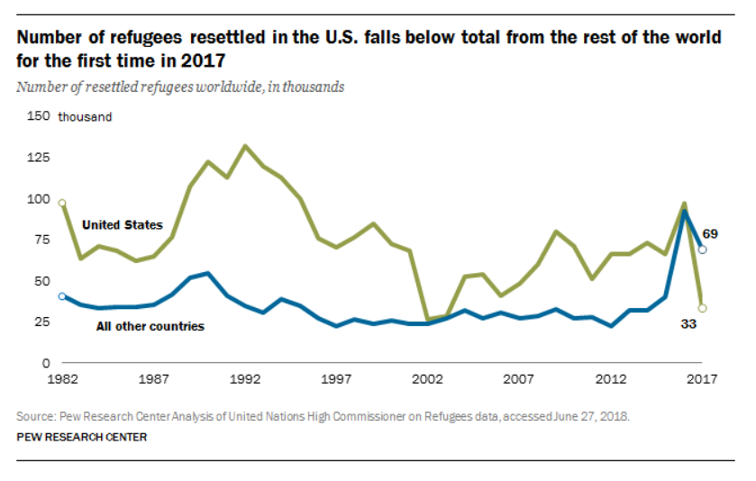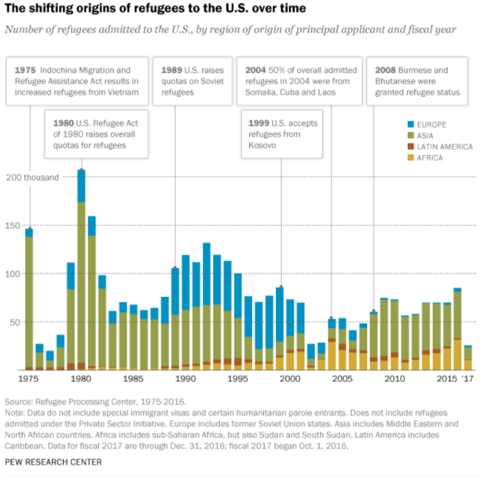

Figure Number of Refugees resettled in the U.S. Falling (PEW Research)

Figure Shifting Origins of Refugees to the U.S. over time (PEW Research)

### 1.2.4 European Asylum-Seeking Policy

The aim of the EU’s asylum policy is to offer appropriate status to any third country national requiring international protection in one of the Member States and ensure compliance with the principle of non-refoulement. To this end, the Union is striving to develop a Common European Asylum System.

1. Articles 67(2), 78 and 80 of the Treaty on the Functioning of the European Union (TFEU);
2. Article 18 of the EU Charter of Fundamental Rights

#### 1.2.3.1 Asylum Seekers 2008-2018

Asylum is a form of international protection granted to the applicant/individual who does not feel safe or protected in his/her country of citizenship and has threat of persecution based on race, religion, nationality or ideology. The EU states or territories provide the protection and provide safe place to live to the individual. The EU – European Union was first established in 1993 in Maastricht, Netherlands. Initially, in total 12 countries were a part of European Union. Today, the EU has 28 countries as their part.

According to the data published by Eurostat, in 1992, the EU received numerous applications (600,000 plus applications) seeking asylum from Yugoslavia. In year 2001, the application count decreased from 600,000 to 424,000 application and less than 200,000 in 2006.

* **Total number of Asylum applications received by EU by Non-EU Citizens**

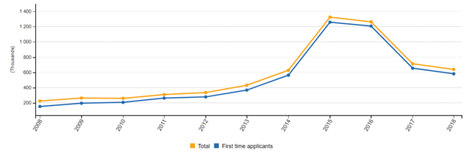

Figure 4 Application Volume over Time

***Note:***

* *Croatia was not included from the study*
* *First-time applicants: 2008: Bulgaria, Greece, Spain, France, Croatia, Lithuania, Luxembourg, Hungary, Austria, Romania, Slovakia and Finland not available. 2009: Bulgaria, Greece, Spain, Croatia,*
* *Luxembourg, Hungary, Austria, Romania, Slovakia and Finland not available. 2010: Bulgaria, Greece, Croatia, Luxembourg, Hungary, Austria, Romania and Finland not available.*
* *2011: Croatia, Hungary, Austria and Finland not available. 2012: Croatia, Hungary and Austria not available. 2013: Austria not available.*

## 1.3 Factors of Immigration

This next section discusses the economic, social, and environmental factors that lead to the decision to migrate.

### 1.3.1 Economic Factors

As of 2015, there are approximately 244 million immigrants around the world, with the majority of them living in developed countries. Approximately 19% of these immigrants live in the U.S. alone. Immigration numbers have almost doubled in the last 50 years. Research shows that the shift of population from one location to other impacts not only the Economy of the country where people immigrate to, but also to the country where people emigrate from.

Throughout history large groups of people have immigrated from one part of the world to another. There are many different complex reasons behind these immigrations such as economic hardships, social or cultural pressures, political or military oppressions etc. However, in this paragraph only the economic factors are discussed in detail. Furthermore, the impact on the economics of the sending and receiving countries, from these immigrations, is also discussed in detail.

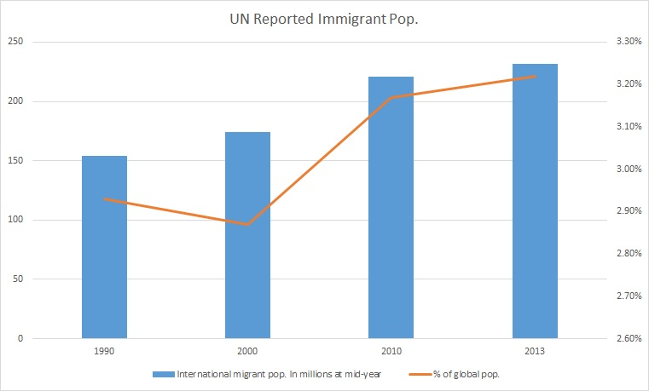

Figure 5 Migrate Estimates (U.N)

Source: <http://www.un.org/en/development/desa/population/migration/data/estimates2/estimates15.asp>

#### 1.3.1.1 Economic Reasons for Human Migration

The economic reasons for immigration are usually fueled by people’s desire to seek an improved quality of life. The lack of employment, entrepreneurial and or educational opportunities are usually the economic factors that motivate people to take the risk of migrating to a different place. In most cases, people that migrate are the ones that come under the category of low-income citizens and most of the immigrations are done from developing countries to developed countries. This phenomenon is evident, considering the fact that in order to achieve an improved standard of living, it is essential to move to a place, which has better economic conditions.

According to the net migration data of the World Bank, in 2017, the top five countries with the maximum number of net emigrants were India, Bangladesh, China, Syrian, and Arab Republic & Pakistan. China being on the list is evident considering it is the most populated country in the world. India, Bangladesh and Pakistan are the most populated countries of the South Asian region and each one of them is categorized as a ‘developing’ country. The lack of resources and overpopulation, in these countries, are the prime reasons for their significant net migration numbers. Syria has the maximum net migration of a single year, in 2012, which was primarily because the country has been in civil war since 2011.

According to the same aforementioned database, top five countries with the maximum number of net immigrants in 2017 were United States, Germany, Turkey, Canada and the United Kingdom. Each of these countries are categorized as ‘developed countries with the United States, Germany and the UK being amongst the most powerful and economically dominant countries of the world. Canada adopts relatively open immigration policies because it occupies a significantly large area with proportionally very little native population hence inviting immigrants to enlarge its workforce. Turkey receives most of its economic migrants from nearby developing countries, towards its Asian side, such as Armenia, Moldova, Georgia, Iran, Azerbaijan and other countries from Central Asia.

#### 1.3.1.2 Economic Impact of Human Migration

##### Positive Impact

The majority of the research indicates that immigration has a positive economic impact on both the sending and receiving countries. According to a research paper written by Ana Maria Iregui, “Studies show that the elimination of barriers to migration would have profound effects on world GDP, with estimates of gains ranging between 67 and 147 percent.” According to the Centre for Global Development, opening all borders could add $78 trillion to the world’s GDP.

Some research also suggests that the reduction in native employment due to automation can be offset by immigration considering the influx of immigrants increases the overall demand, consequently pushing the natives out of low-skilled manual labor into better paying occupations.

As far as fiscal impact is concerned, studies show that immigration has a minimal effect although the effects tend to be positive. According to a 2007 literature review by the Congressional Budget Office, "Over the past two decades, most efforts to estimate the fiscal impact of immigration in the United States have concluded that, in aggregate and over the long term, tax revenues of all types generated by immigrants—both legal and unauthorized—exceed the cost of the services they use."

Immigrants have also been linked to higher achievements in education and greater invention, specifically in the United States. Many startup companies in the United States, worth billions of dollars, are founded by either immigrants or employee immigrant workers in highly ranked positions. Recent statistics have shown that foreign-born students account for more than 50% of the total PhD student population in American Universities.

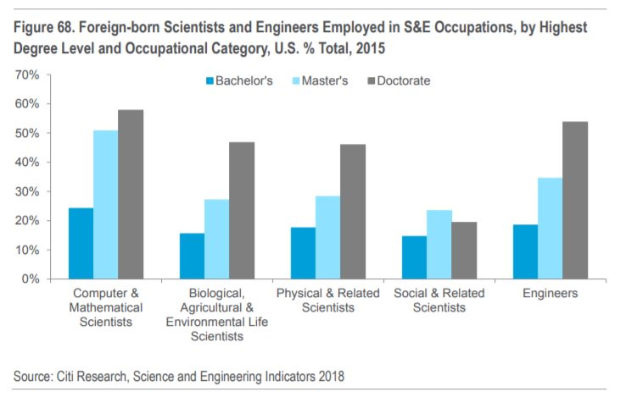

Figure 6 Foreign-born Scientists and Engineers Employed in S&E Occupations (US) (AEI.ORG)

Source: <http://www.aei.org/publication/how-immigration-boosts-american-economic-growth-and-innovation/>

Research also shows that the sending economics of the sending countries also benefit from immigration. The primary reason for this is remittance which is the money these immigrants transfer back to their less developed countries from what they earn in the developed countries. “For many developing nations, remittances received make up a significant portion of their economies often receiving over 10% of their GDP in remittances each year.”

##### Negative Impact

There are arguments against the economic benefits of immigration. The primary argument is with respect to the fact that an immigrant worker is willing to work for an income lower than what a native low skilled worker would demand because the immigrants expected standards of living are lower than that of the native. This forces the native low skilled workers out of jobs. This also results in greater income inequality in the native population.

A key factor to identify is the immigration of people with no documentation or in other words illegal immigrants. These immigrants work outside the native country’s economic system and usually get paid in cash from employers. This exchange of money has to be done ‘under the table’ and does not get taxed. This not only encourages employees to underpay the illegal immigrants and not employ legal native employees, but it also forces the illegal immigrants to remain below the poverty line hence increasing the rate of crime and consequently leaving a negative impact on the economy.

Another argument against immigration is related to asylum seekers. When immigrants apply for an asylum, they are usually given working privileges and welfare benefits right away. After their case is reviewed the authorities decide whether the applicants are eligible and if not, they get deported back to their native countries. This process can take up to years due to the backlog of a very high number of applicants, as is the case in the US. “In March 2018, there was a backlog of 690,000 deportation cases under review”. This allows anyone in the world to apply for asylum by making up false oppressive cases and benefitting from the welfare system for long periods of time.

### 1.3.2 Environment Factors

Migration is a normal part of the development process. Unmanaged and unexpected climate migration intensifies problems such as deterioration of ecosystems, slowing economic development, disruption of human and political rights, and increase in internal conflicts (24, 25). The international community observes that the current mitigation of climate change may not be enough to prevent significant harm (26).

The degradation of the environment and increase in natural disasters are key drivers for migration and displacement (27). Several factors determine success of emigration as an adaption strategy to the adverse effects of global warming. Factors that increase migration due to climate change include quality and quantity of economic, social, and geographical resources available, the vulnerability of the place of origin and the political/economic situation of the destination country (27).

In a study in 2018 by Rigaud, de Sherbinin, Jones, Bergmann et al projected more than 143 million internal migrants by 2050 across sub-Sahara Africa, South Asia, and Latin America due to environmental changes (28). The volume of potential migrants indicates that migration and displacement are critical issues within the context of climate change that requires international attention (27).

Environmental drivers of migrations in poor regions where agriculture is a dominant economic driving force increasingly focuses on evaluating the impact of climate change. Without significant adaptation measure, regions home to poor and food insecure populations will suffer negative impacts when productions of crops decline drastically. Furthermore, natural disasters such as volcanic eruptions, typhoons, hurricanes, landslides, and earthquakes will continue to increase displacement and affect migration in countries with poor infrastructure to support the effects of those phenomena (27).

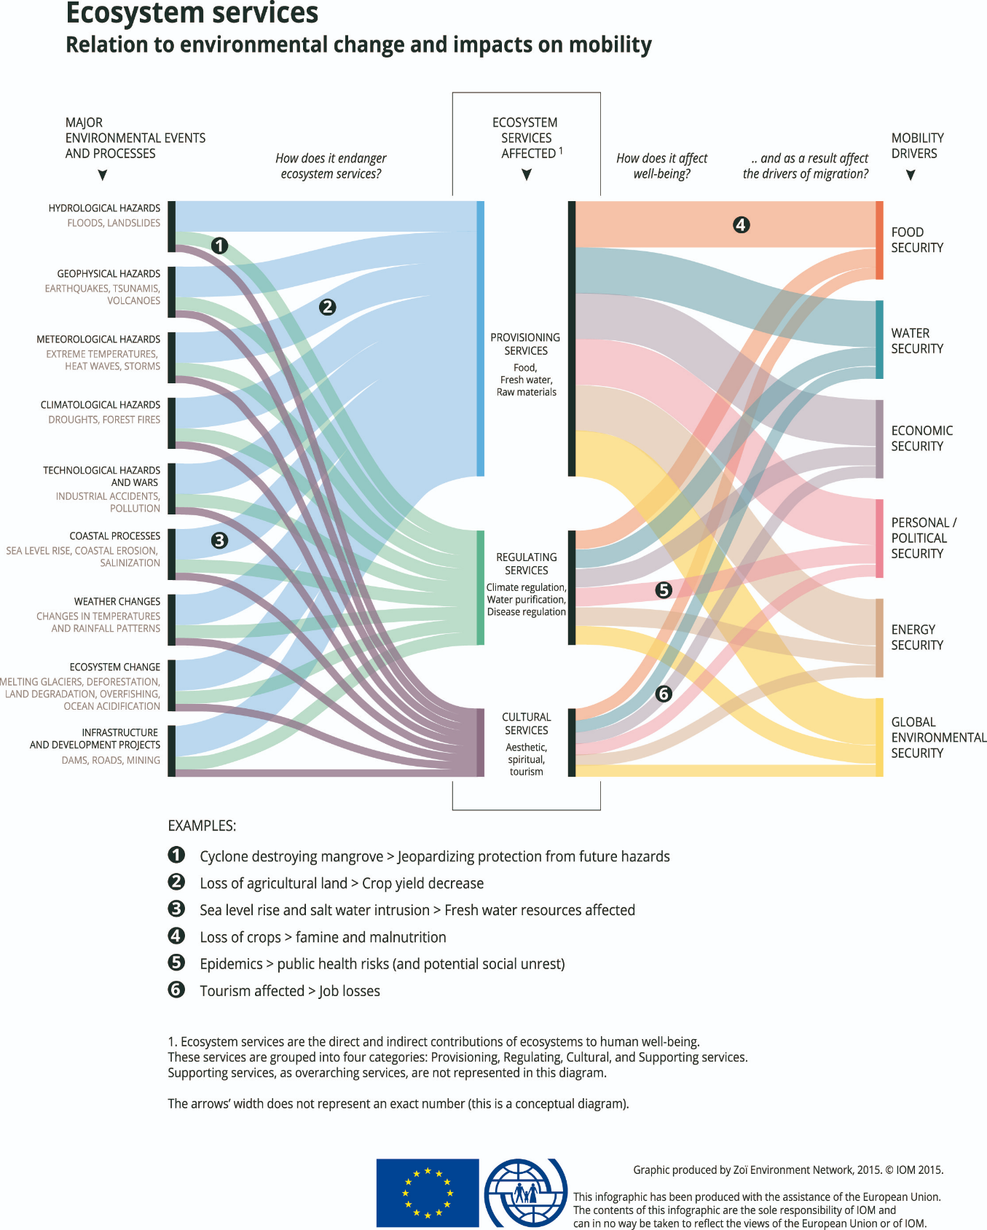

Figure 7 Ecosystem Services and Mobility Drivers (source: Environmental Migration: <https://environmentalmigration.iom.int/infographics> )

#### 1.3.3.1 Agricultural (Farming and fishing)

Climate change affects food production in low latitude countries; the higher temperatures affect the crop yield as well as water scarcity. Water scarcity affects both the crop yield but also livestock production and fisheries (28). Productivity declines increase poverty and food insecurity (28). Research by Feng, Krueger and Oppenheimer (2010) examined the link between climate productivity changes in agriculture and out-migration with Mexico (to the United States). They found a linear correlation between crop yields and emigration and predicted an increase in migration to the United States (thus inferring similar behaviors to other migrate-receiving countries).

As the world population continues to grow, the demand for food and water exacerbates the competition for these resources prompting migration for some individuals and families. Within the context of famine and drought, food security and migration have a direct relationship because the people are forced for migrate to escape hunger (28), however the migration is frequently temporary. Migration is often a strategy used by farmer to cope with income uncertainty as well as food insecurity. Poorer rural households tend to send one or more family members to urban areas to work in non-agriculture sectors to reduce the risk of hunger and extreme poverty (28). Furthermore, the evidence suggests that households with members that are anxious about food security, often decide that an adult should migrate in search of employment to support the family better (28).

Additionally, adequate humanitarian assistance is a consideration for internal migrants (individuals migrating within the country and those that are refugees to the country) (28). Support for these communities brings social benefits in stabilization of these economies, protecting families and providing opportunities for economic development (28).

#### 1.3.3.2 Environmental Displacement

Environmental displacement occurs for several reasons. Tsunamis, landslides, flooding, rising sea levels, and drought are often cited as reasons for individuals to migrate. The Office of the UN High Commissioner for Refugees (UNHCR) estimates that nearly 145 million people have been displaced in the last six years with an anticipated 250 million persons due to environmental factors in the next 35 years (38).

In a study by Oliver-Smith (2012), upon reviewing policy and laws around environmental and migration policies, the terms ‘environmental refugee’ and ‘environmental migrate’ is fundamentally rooted in the “idea” that nature is being blamed for human behavior relative to ethnic and political violence, migration and famine. By blaming “nature”, it allows governments and agencies to avoid responsibility for the relocation of individuals (39). Furthermore, a semantic declaration must be made to evaluate the distinction between nature and the environment. Nature does not displace individuals but is an array of human generated forces (massive production of greenhouse gases), that are transforming the global climate, thus impacting “nature” (39). The weather and erosion displace people seem like natural forces but are in fact a result of human interference. The environmental processes that is a combination of human and nature forces (39). That said, there are currently no global monitoring systems that measure population displacement and environmental change as confirmed by Hunter, Luna and Norton (2018) (34).

# 2. Theory and Model Development

A study by Black et al. (2011) evaluated the micro-, meso- and macro-level contextual factors of immigration and the decision to migrate. Macro-level factors include social, culture, economic, and political structures. Furthermore, the research also found historical-political context to influence migration.

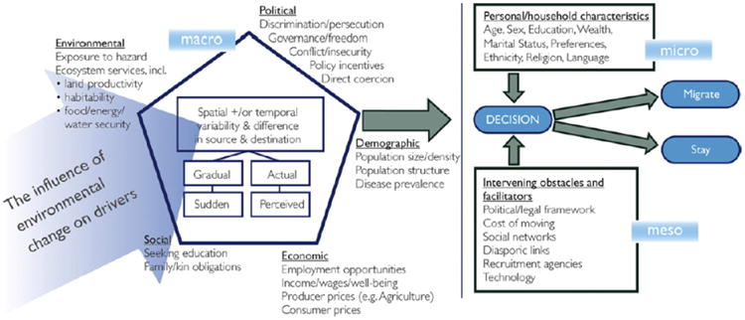

Figure 8 Conceptual Framework for Drivers of Migration by Black et al. (2011)

(A conceptual framework for the drivers of migration as presented by Black R, Adger WN, Arnell NW, Dercon S, Geddes A, Thomas D. 2011. The effect of environmental change on human migration. *Glob. Environ. Change*. 21S:S3–11, page S5.)

Additionally, a study by Hunter, Luna, and Norton (2018) found additional contextual characteristics such as social networks and household compositions that also affect migration while supporting the theory model by Black et al (2011). Their study however, identified the lack of sociologist contributions toward the study of inequalities, perceptions and social behavior (Hunter, Luna, and Norton, 2018).

In following the model from Black et al (2011), and taking in considerations from Hunter, Luna, and Norton (2018), the model includes factors that have not been studied or measured in depth to understand the strength of the “relationship”. Additionally, it lacks the functional outcomes the migrant is seeking to obtain.

## 2.1 Hypotheses and research questions

H0: What are the factors leading to the current immigration crises and what are the recommendations to improve the situation for immigrants internationally?

H1: What is the flow of international migration today? Where are migrants moving and which countries are accepting them?

H2: What are the primary economic factors and what are the economic outcomes?

H3. What are the primary social factors and what are the social outcomes?

H4: What are the primary environmental factors and what are the environmental outcomes?

H5: What are the independent variables and how do they affect the decision to migrate (cost, policy, and migrant status)?

In order to understand the degree of factors, the decision to migrate, and the functional outcomes from migration, the model in Figure 9 reflects the determinants found in both the literature and publicly available datasets from reliable sources.

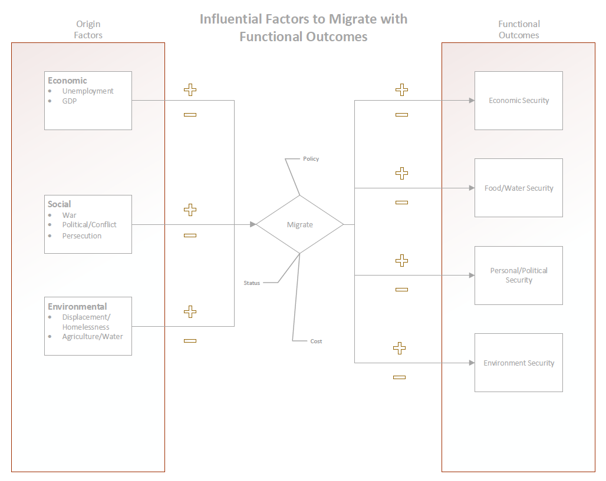

Figure 9 Influential Factors to Migrate with Functional Outcomes

In this model, Origin Factors, such as economic, social and environmental have varying degree of influence on the decision to migrate. Additionally, external factors such as policy, cost and status influence the decision separately. So, for example, migrants seeking economic security will migrate from when they are coming from high degrees of economic origin factors, such as unemployment or low GDP. If that relationship is low in strength, the decision to migrant may not be because of economic origin factors. Additionally, immigrants may be seeking more than one functional outcome and facing varying degrees of economic, social and environmental factors.

# 3. Analysis & Methodology

Section 3 explains the data set for each hypothesis and the analysis completed using that data set.

## 3.1 Flow of International Migration

H1: What is the flow of international migration today? Where are migrants moving and which countries are accepting them?

Dataset: The dataset used to display international migration comes from the U.N. Migrant Stock. The dataset includes three Excel workbooks: (a) UN_MigrantStock_2017.xls, (b) UN_MigrantStockByAge_2017.xls, and (c) UN_MigrantStockByOriginAndDestination_2017.xls.

The data was structured using Major areas and regions and listed out 232 countries covered by their development group, major area and region. To study H1, it is necessary to see where the volume of migrants are located by country. Below, the data set was articulated by year, to view the volume by destination. The coloration is mapped based on volume of total stock. Blue represents positive migrant stock and orange represents negative stock, meaning more individuals are leaving the country than being replaced by migrants. The size of the bubble represents the volume growth.

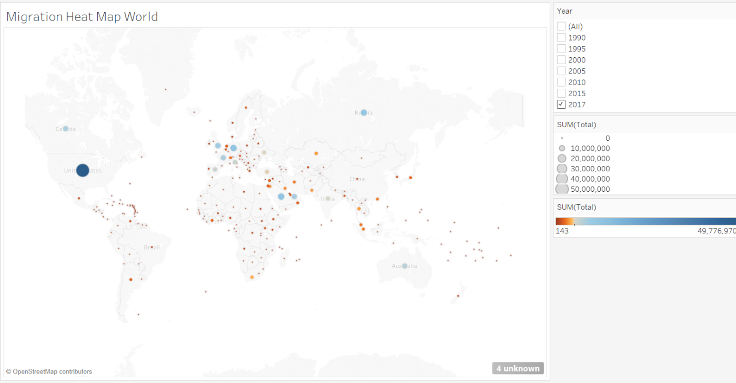

Figure 10 World Migrant Stock 2017 Heat Map

As can be observed in Figure 10, the United States contains the majority of international migrants. The almost 50 million incoming immigrants make up for about a seventh of its population. Other countries that take a large number of immigrants are Germany, Russia, Saudi Arabia and the United Kingdom.

When viewing the distribution of immigrants over different time periods, a couple of things can be observed. Although the male to female ratio seems to be even for each of these time periods, the 75+ age group stands out a lot for immigrants, which is not usually the case for populations of countries. In addition, the total number of immigrants has increased a lot and the distribution of age groups has changed too. For instance, the largest age group in 1990 (30-34) was less than four times larger than the smallest age group (70-74). However, in 2017 the largest age group (30-34) was about seven times larger than the smallest age group (70-74).

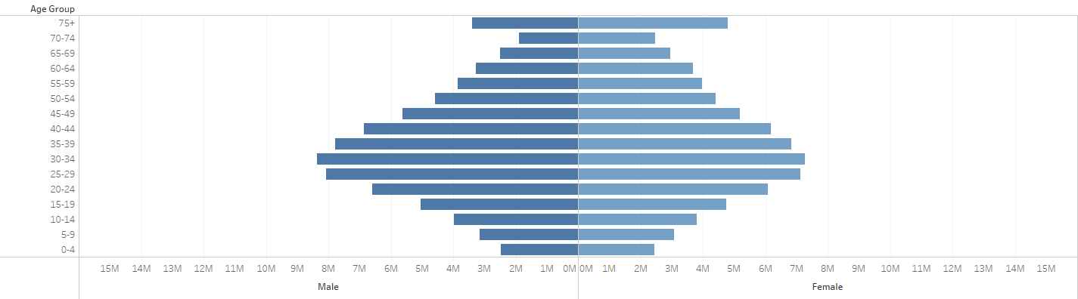

Figure 11 Distribution of Male/Female Immigrants Worldwide, 1990

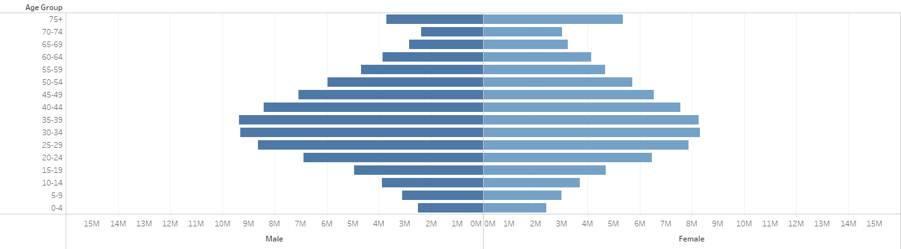

Figure 12 Distribution of Male/Female Immigrants Worldwide, 2000

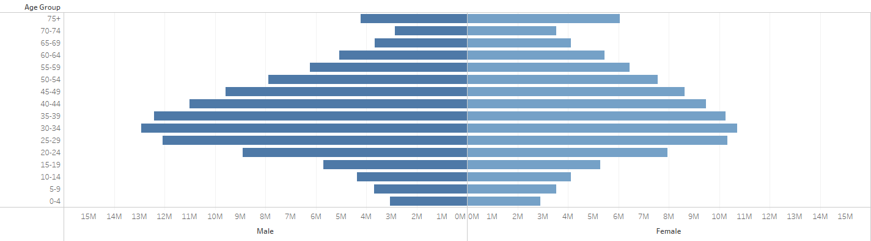

Figure 13 Distribution of Male/Female Immigrants Worldwide, 2010

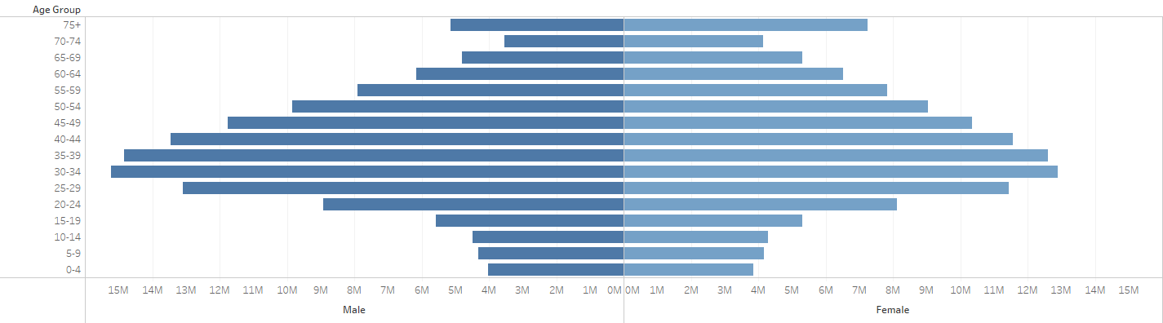

Figure 14 Distribution of Male/Female Immigrants Worldwide, 2017

A possible explanation for this could be that immigrants, who want to start a new or better life, often want to bring their parents and grandparents with them. The volume of immigrants has grown over the past decades. However, rather than just measuring the growth rate, it is also very interesting to see how the immigration flow has changed for different region. Chord diagrams can be used to effectively show relationships between two points, while the thickness of the arch connecting these two points is used to show the volume. Figure 15 shows six chord diagrams between 1990 and 2015 with 5-year intervals.

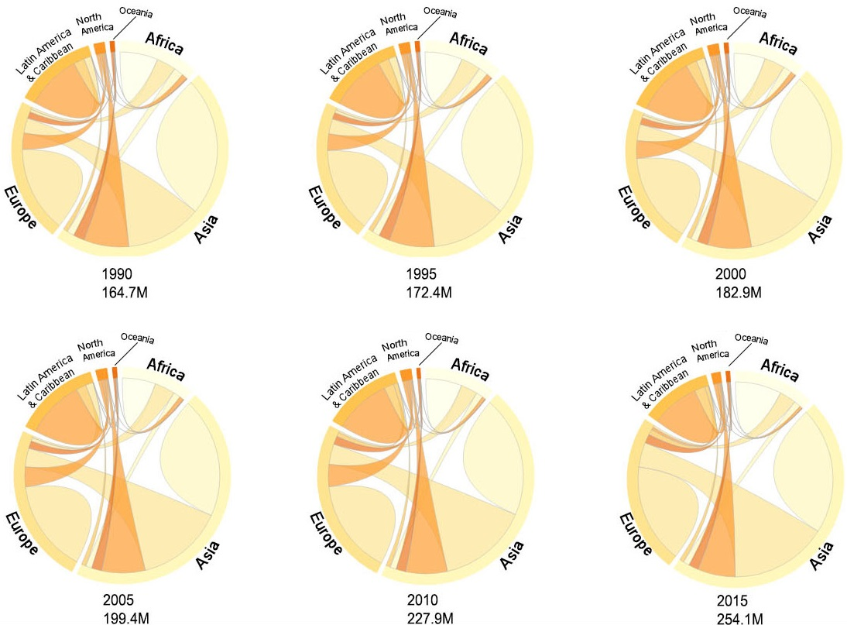

Figure 15 Migrant Flow between World Regions (1990-2015)

Although the chord diagrams look almost identical at first glance, there are differences that can be observed. For instance, between 1990 and 2015 immigration from Latin America and the Caribbean has decreased and immigration from both North America and Asia to Europe has increased.

### 3.1.1 European Migration

Figure 16 shows the distribution of immigrants in Europe in the year 2017. Since the percentage of immigrants with an ‘unknown’ origin is very low, the administration of immigration in Europe appears to be accurate. It can also be observed that Germany takes the largest number of immigrants by far, and that the first five countries (Germany, United Kingdom, Spain, Italy and France) together take the very vast majority of all immigrants in Europe. However, it should also be noted that that these countries are some of the largest countries on the continent, both in terms of area size and population.

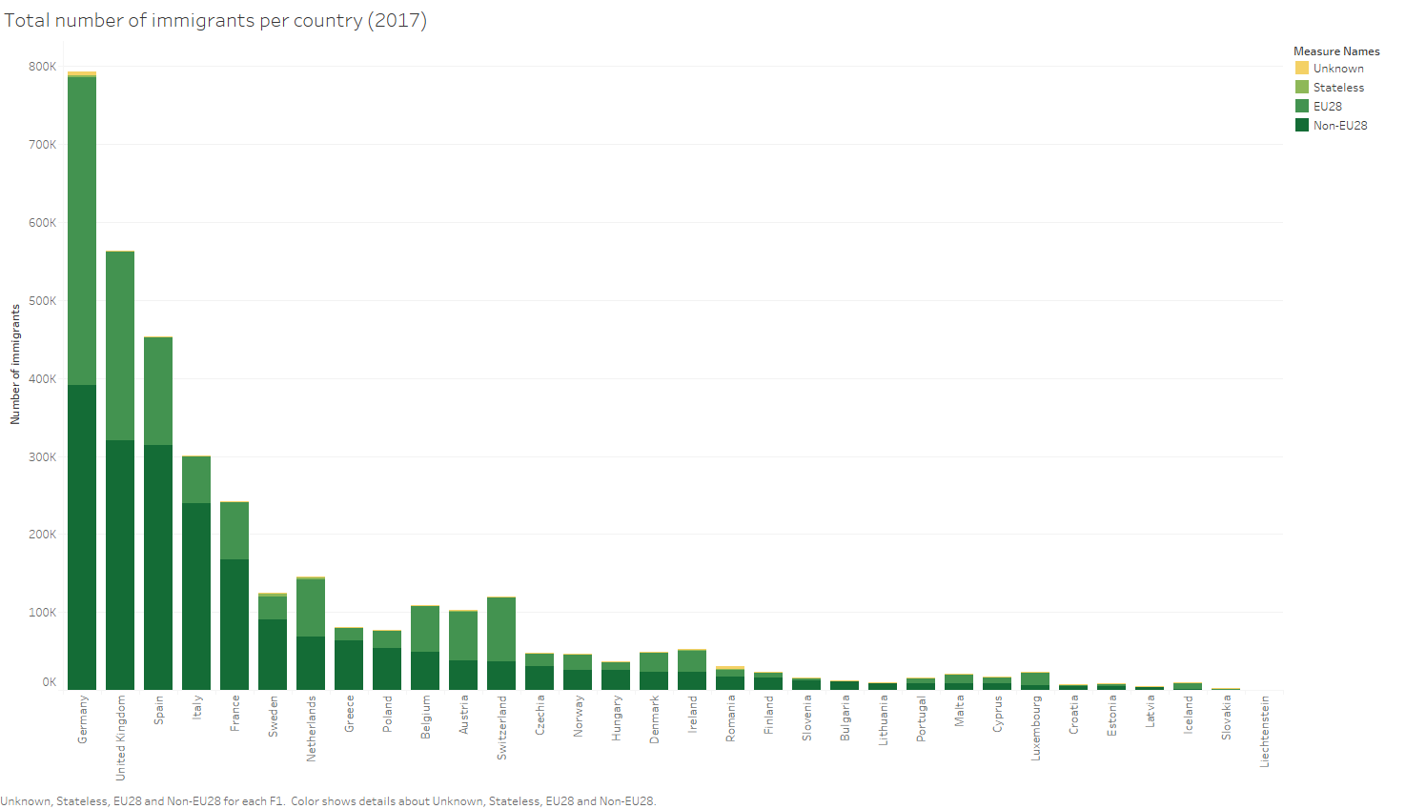

Figure 16 Total Number of Immigrants per European Country (2017)

Therefore, it is more interesting to compare the number of non-EU28 immigrants for each country to its own population and observe the relative distribution of immigrants in Europe. Figure 2 shows the immigrants per 1000 inhabitants of each European country. Here, some of the smallest countries appear to take the highest number of immigrants when compared to their own population. In Figure 17, Spain, Germany and the United Kingdom rank average, with Italy and France ranking below average.

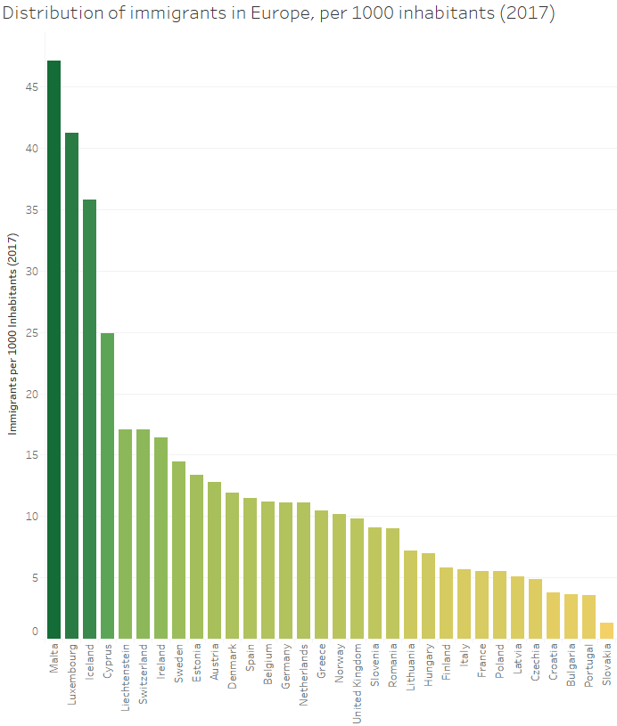

Figure 17 Distribution of Immigrants in Europe per 1000 Inhabitants (2017)

### 3.1.2 United States Immigration

Figure 18 shows the distribution of immigrants from their country of origin. It is very clear that a majority of the migrant stock in the United States comes from Mexico. In fact, the total number of immigrants from Mexico outperforms all other countries (including China, India and Philippines). And as such, this graph also reflects some of the reasoning behind the current border control policies in the United States.

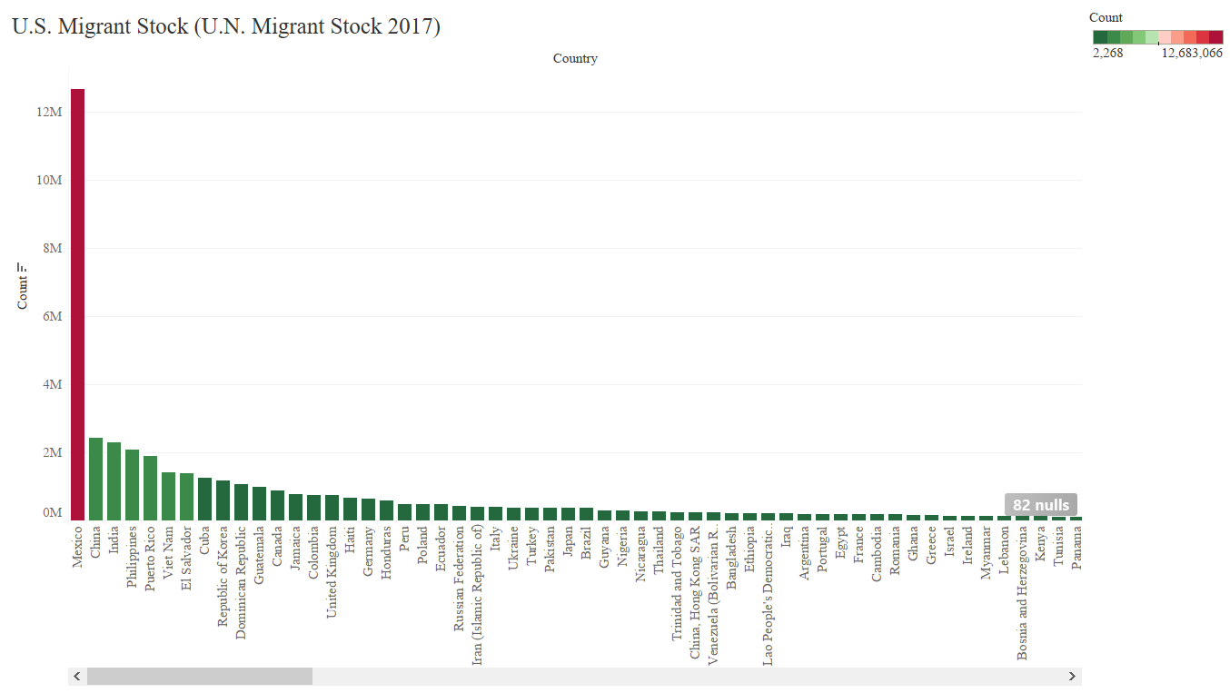

Figure 18 U.S. Migrant Stock

### 3.1.3 Volume of Illegal Immigration

Illegal immigration is difficult to track and to estimate. In Europe, legal citizens are able to flow back and forth between countries while in the United States; there is no standard data set or reliable data tracking to evaluate the volume of illegal immigrants other than through employment and arrests. Figure 19 shows arrests of illegal immigrants at the U.S. Border. It is observed that a majority of the illegal immigrants arrested are from Mexico.

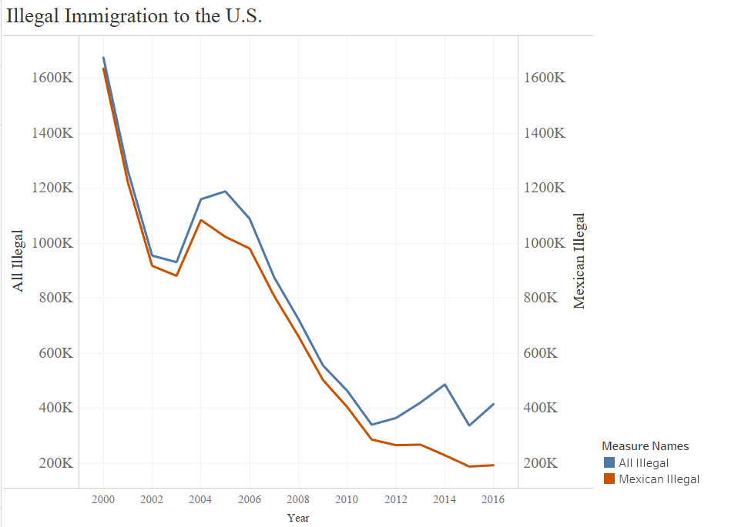

Figure 19 Illegal Immigration Arrests at U.S. Borders

## 3.2.0 Factors of Immigration

### 3.2.1 Economic Factors

H2: What are the primary economic factors and what are the economic outcomes?

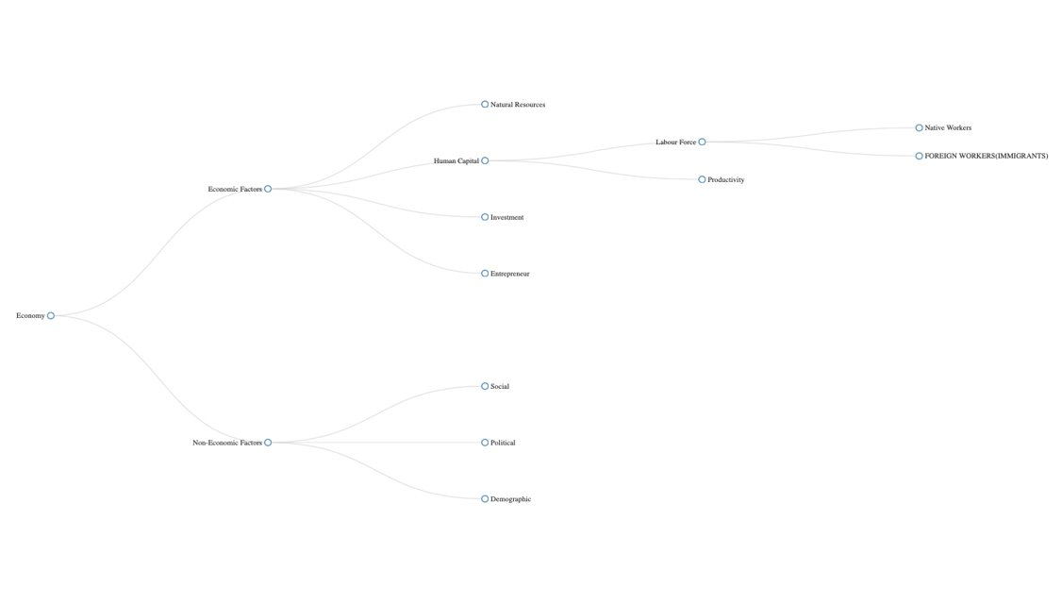

Figure 20: Economic Growth Hierarchy Chart

As mentioned earlier, Economy is impacted by a complex network of interlinked factors therefore the first question that needs to be addressed is how Immigration can be linked to the economy. As shown in Figure 20, Economic growth is impacted by economic and non-economic factors. One of the economic factors that impact Economic growth is Human Capital which is calculated by the quantity of labor force in a country and the productivity of that labor force. The quantity of labor force in a country can be divided into people who are native born and people who are foreign born. The population and demographics of these foreign-born people represent immigration.

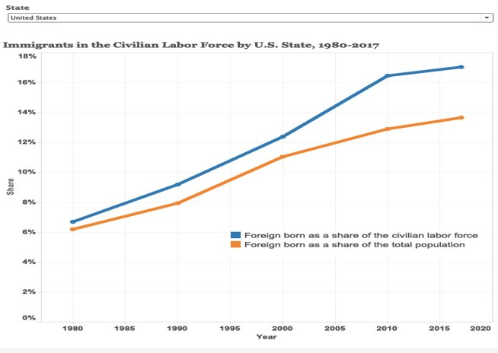

Figure 21: Immigrants in the civilian Labor Force, US, 1980-2017

Figure 21 contrasts between the share of the foreign born amongst the civilian labor force compared to foreign born amongst the total population. The increasing trend of both shares, over the last 60 years, coincides with the fact that the number of immigrants in the U.S. has always increased as a result the labor population that are foreign born has also increased. However, we need to account for the fact that there are also many immigrants that are not part of the labor force such as retired individuals, children and unemployed males and females. The increasing separation between the 2 trend lines indicate, that with time, the percentage of working immigrants coming in the U.S. compared to non-working immigrants has increased. If more people entering the U.S. are taking part in the U.S. labor force and paying taxes, compared to people who are not paying taxes, it means that they are contributing towards economic growth. It is also to be noted that people who do not pay taxes are not necessarily negatively impacting the society, as they still pay sales taxes on the goods they purchase.



Figure 22: Unauthorized immigrant population by State, 2016



Figure 23: Unauthorized Immigrants in Major US states

Immigrants can be further divided into 2 categories, namely authorized and unauthorized. Authorized immigrants compromise of individuals that are hired for jobs, family members of U.S citizens, Asylum seekers etc. In terms of economics, these group of people are generally well accounted by the government and their contribution towards economic growth can be monitored, calculated and predicted relatively easily. Unauthorized immigrants compromised of immigrants that entered the country illegally and even though they might pay sales taxes and/or reduce labor costs, their accountability and impact on economics is very difficult to estimate and as part of this research, it is crucial to understand what the percentage of these unauthorized immigrants are within a country. Figure 22 and Figure 23 show the demographics of unauthorized immigrants in different states of the US.

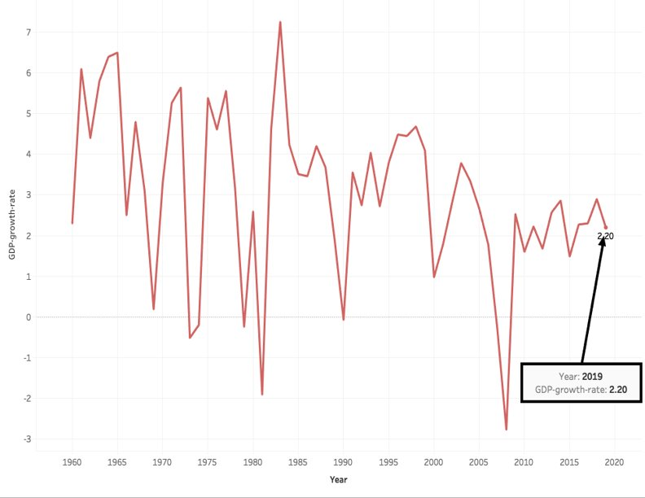

Figure 24: US, GDP growth rate since 1960

The U.S is a good example to consider when showing how immigration impacts economy, considering U.S. is the country with the largest number of immigrants in the world. Figure 24 shows how the economic growth rate of the U.S. has risen and fallen since 1960. The reasons behind these fluctuations vary, some examples being economic recessions, oil crisis, tech booms etc. It is not accurate to directly link immigration to GDP because there are other factors that impact GDP significantly more than immigration. A better approach would be to analyze the number of immigrants in specific industries in the U.S. and how those industries impact the overall GDP of the US. Figure 25 shows 3 bar charts, the left most bar chart indicates the distribution ratio for different industries in the U.S. The distribution ratio is the likelihood of a foreign-born worker being employed over a native worker. The bars labeled in green are all the industries where foreign-born workers have a higher chance of being employed and the corresponding 2 bar charts are an indication of how those industries impact employment and also the GDP of the U.S.

*Figure 25: Relationship between immigrants, industry & GDP*

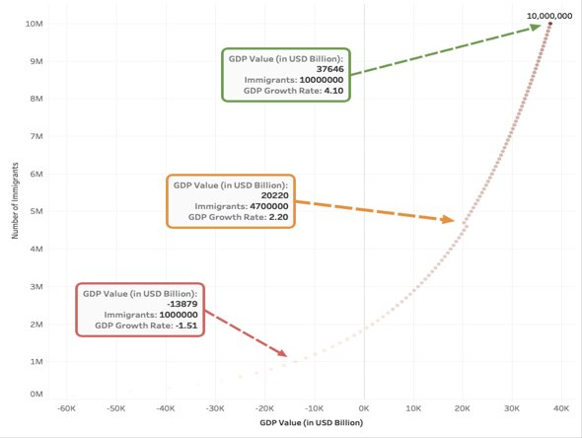

Figure 26: GDP relationship with Number of Immigrants

An article written by Lena Groeger references a graph that shows how the U.S. GDP is expected to grow, up until 2030, depending on the number of immigrants increased every year. The graph is yielded from predictive analysis performed by Moody analytics. That predictive analysis considers the overall GDP not the GDP per capita and it does account the fiscal costs of adding more immigrants to the country. The results yielded from the analysis indicate that for every 1% increase in U.S. population the GDP rises by 1.15%. Figure 26 is a representation of the same predictive analysis from a different perspective. It shows how the GDP changes as the number of immigrants in a country increase and the increasing trend proves the hypothesis that an increase in the number of immigrants increases the overall GDP of a country.

### 3.2.2 Social Factors

H3. What are the primary social factors and what are the social outcomes?

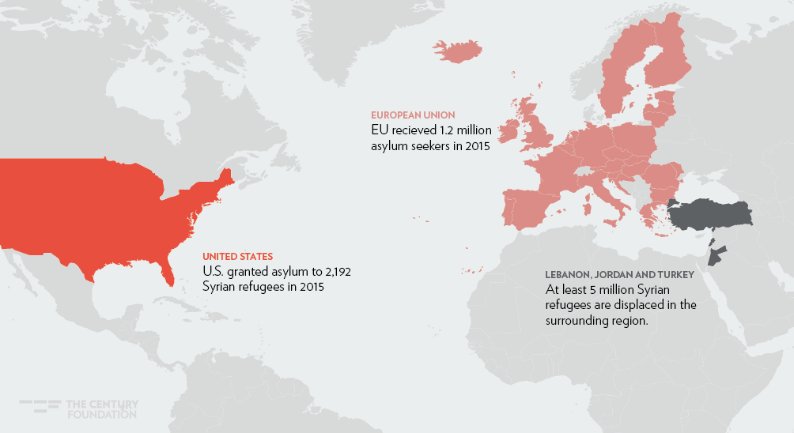

United States and European Union faced Refugee Crisis from 2015 to 2016. The purpose of study the impact of social factors on immigration especially from refugees and asylum seekers provides overview of how increased refugee/asylum seekers impact these developed countries in certain ways. By comparing results from pulling insights through visuals, this provides readers a strong understanding of how the progress of asylum seeking between U.S. and Europe. Hence, there is a section diving deeper into European GDP impact by the arrival asylum seekers into European countries.

**Asylum application and refugee data for U.S. were retrieved from United Nations High Commissioner for Refugees.

**Types of Procedures**

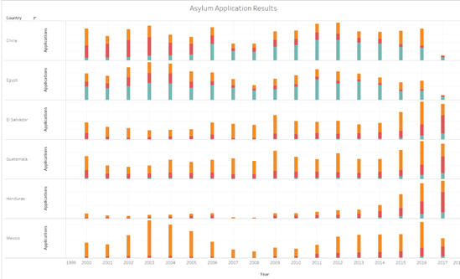

Figure 27Asylum Application Results from Executive Office for Immigration of United States

These are six top countries with most asylum applications for the United States, including China, Egypt, El Salvador, Guatemala, Honduras, and Mexico. From 2000 through 2008, applications from Honduras were in the low range and started to increase significantly from 2014 through 2017. Before Trump administration was in office, accepted applications from China, Egypt, Guatemala, and El Salvador were seen with the most from China and Egypt. From 2000 through 2016, there were more applications accepted from Egypt than closed nor rejected applications. This figure shows asylum applications processed by Executive Office for Immigration of United States. As mentioned, these applications must be processed within a year after the arrival date to U.S. For individuals coming from El Salvador, Honduras, Guatemala, and Mexico, they were likely to apply at the United States border while individuals from China and Egypt were more likely to reside on U.S soil.

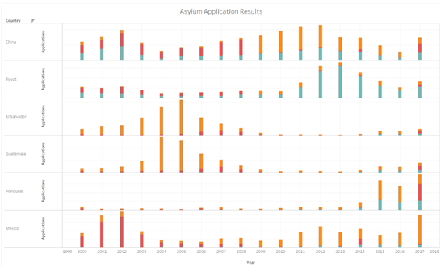

Figure 28 Asylum Application Results from Immigration and Naturalization Services of U.S

These are the six top countries with most asylum applications for the United States, including China, Egypt, El Salvador, Guatemala, Honduras, and Mexico. From 2000 to 2005, the amount of closed cases was significantly high from El Salvador and Guatemala while applications from Mexico were mostly rejected from the U.S. Immigration and Naturalization Services. A case can be closed and has the possibility to be reopened in the future. From 2011 through 2017, an increase trend to accept asylum applications from Egypt could be seen from conflict in politics, social, and religion. Since many LGBT members in Egypt were not recognized by the government, they decided to leave because the Egyptian government thought the sexual orientation of LGBT members are defiant against the government. Moreover, activists are imprisoned and tortured by the government along with civilians protesting the government are persecuted. Egypt is mainly made of Muslim religious follower with decreasing amount of Christianity and other religions among the population especially Christians who are likely to be persecuted.

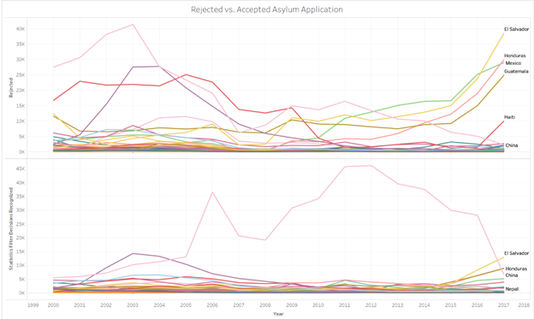

Figure 29 Rejected vs. Accepted Asylum Applications (EO)

From previous figures showing asylum application trends among six countries, the usage of line graph provides deeper understanding. Hence, this figure shows El Salvador shows the greatest accepted application by the Executive Office of Immigration under Department of Homeland Security. The highest peak of acceptance can be seen during 2011 through 2012 under Obama Administration. Between 2007 through 2008, the amount of rejected cases decreased during the Great Recession in the U.S. Starting from 2015 there was a sharp increase in the amount of rejected cases. From 2016 through 2017, there was a sharp decrease in accepted applications from China, while El Salvador and Honduras have steady rises during Trump Administration.

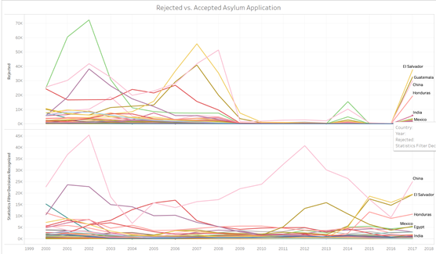

Figure 30 Rejected vs. Accepted Asylum Applications (INS)

From previous figures showing asylum application trends among six countries, the usage of line graph provides deeper understanding. Hence, this figure shows China shows the greatest accepted application by the Immigration and Naturalization Services under Department of Homeland Security. The amount of applications rejected is significantly reduced from 2007 to 2008 during the Great Recession in U.S.

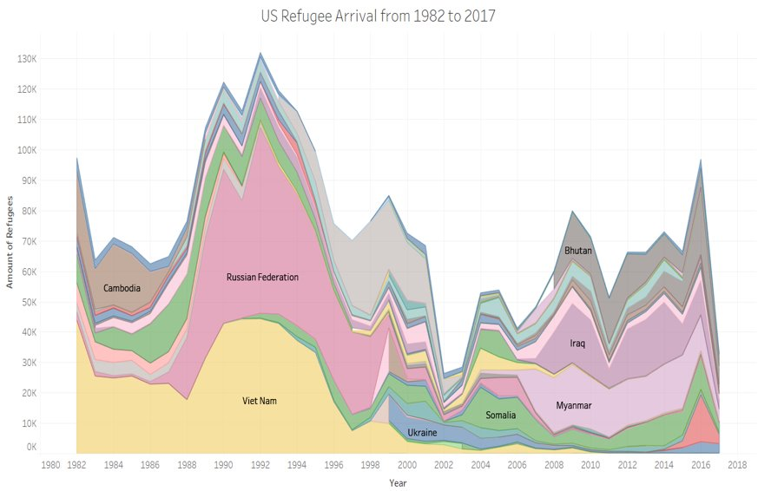

Figure 31 U.S. Refugee Arrival from 1982 to 2017

After the U.S. Refugee Act of 1980 was in effective, the trend of refugee arrival became increasingly noticeable and will be explained further within this section. From 1982 through 2017, the arrival of refugees significantly is increasing due political happenings. In 1982, the surge of refugees entering U.S. were mostly from Cambodia and Vietnam. While the Vietnam War was going on, a group known was Khmer Rouge was trying to convert Cambodia according to the communist model of Mao’s China which started the Cambodian genocide from the extremist policies within the communist model. In addition to Vietnam, a neighboring country of Cambodia was falling in the Domino Theory, a Cold War policy states how a communist government within a country would affect neighboring countries to fall under communist influence. Domino Theory was created by President Dwight D. Eisenhower shows the process of how the noncommunist state would fall to communism after World War 2. Moreover, there was a huge number of refugees coming in U.S. from Russian Federation state with 61,000 who were mostly Soviet Jews in 1991.

Social as one of the origin motivators presented the evidence of why there was increasing trend entering United States during certain period of time. The social factors for refugees to escape their origin country are United States immigration policies change accordingly to accommodate the number of refugees coming from political impact. With U.S. Involvement with Vietnam War from 1955 to 1973, many South Vietnam militants whom U.S. was fighting along were placed in concentration camps by the Communist government. Hence, they were given refugee status to come to U.S. to escape living under communist government from further persecutions.

***European Asylum Application***

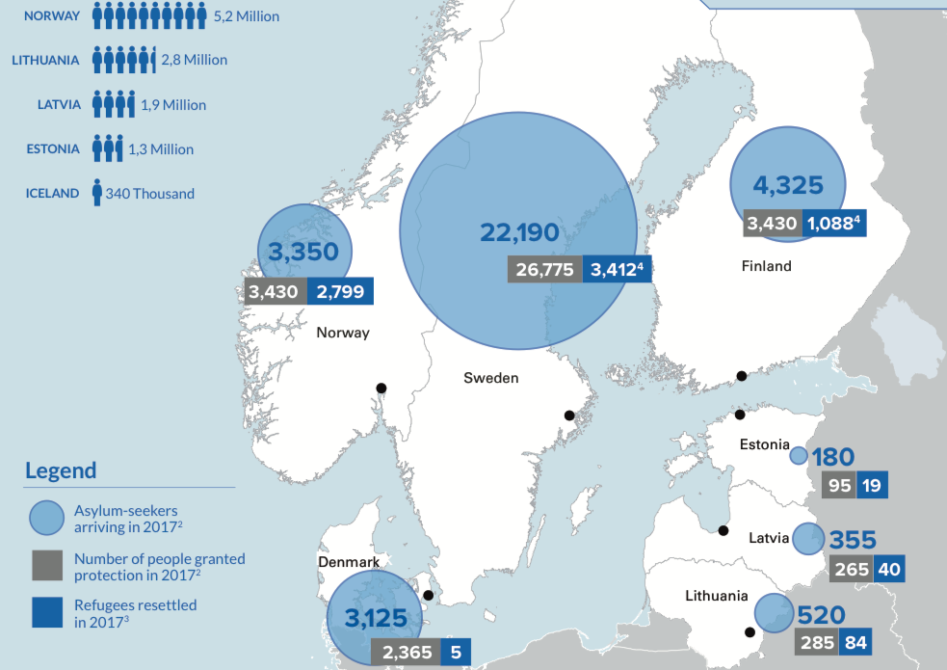

Figure 32 Source: UNHCR: The UNHCR Northern Europe factsheets give an overview of the 2017 data concerning asylum-seekers, refugees and stateless persons in the region.

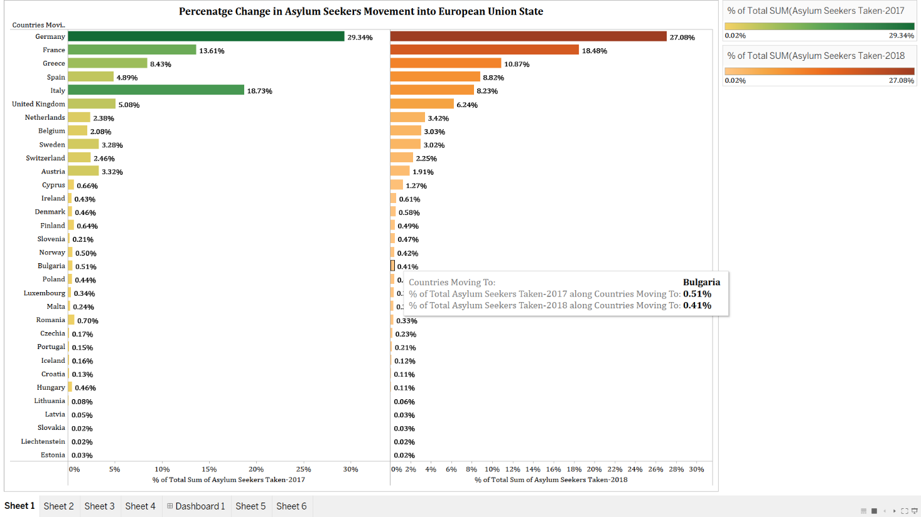

Figure 33. The figure shows the % of Total Asylum Seekers granted asylum in EU countries from 2017 and 2018

The figure above shows how the percentage change in the asylum seekers that are allowed asylum in European Union countries. The statistics are from years 2017 and 2018. Germany as we can see in the figure, has taken the highest number of asylum seekers, that is 161.9 in 2018 and 198.3(in thousands). Dropping the asylum seekers count by 2.26%. France on the other hand accepted more asylum seekers in 2018 when compared to 2017. France accepted 92.0 in 2017 and 110.5 (in thousands) asylum seekers in 2018. Italy accepted 18.73% of Total Asylum Seekers Taken in the year 2017 whereas in 2018 the number decreased to 8.23%.

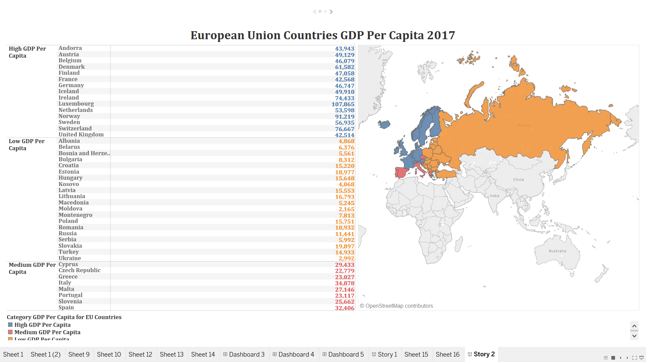

Figure 34 GDP Per Capita for European Union

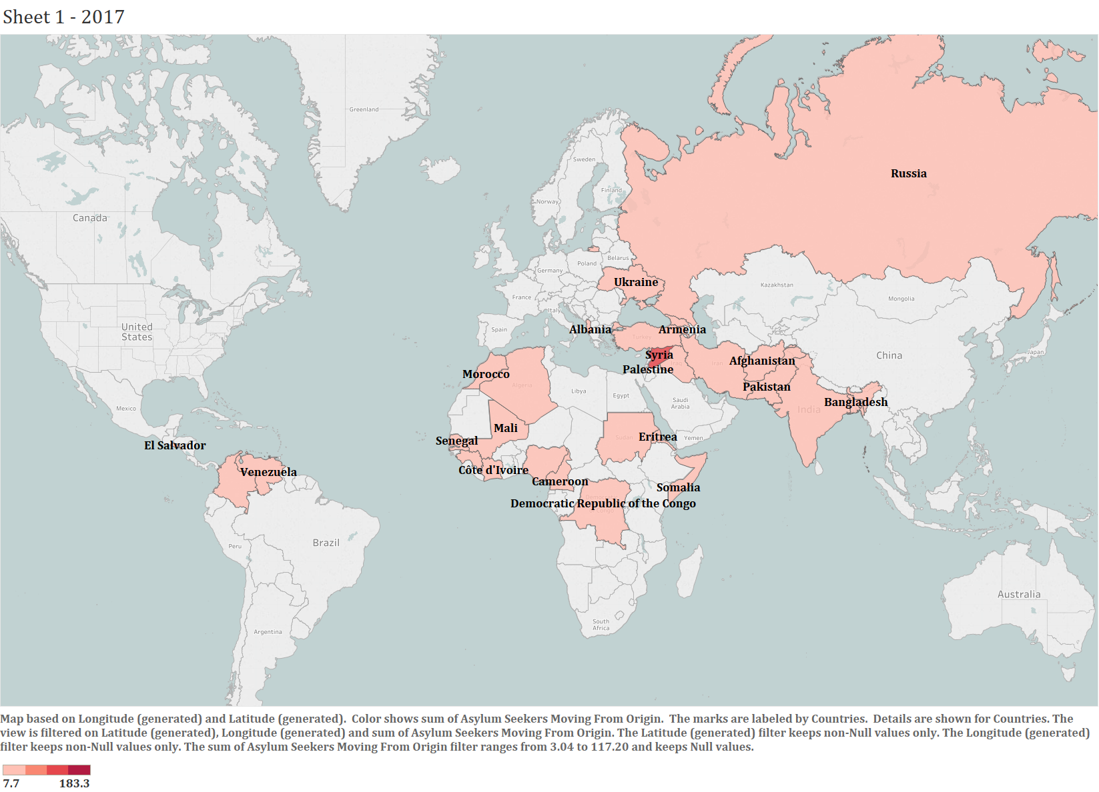

Figure 35 Asylum Seeker Origins

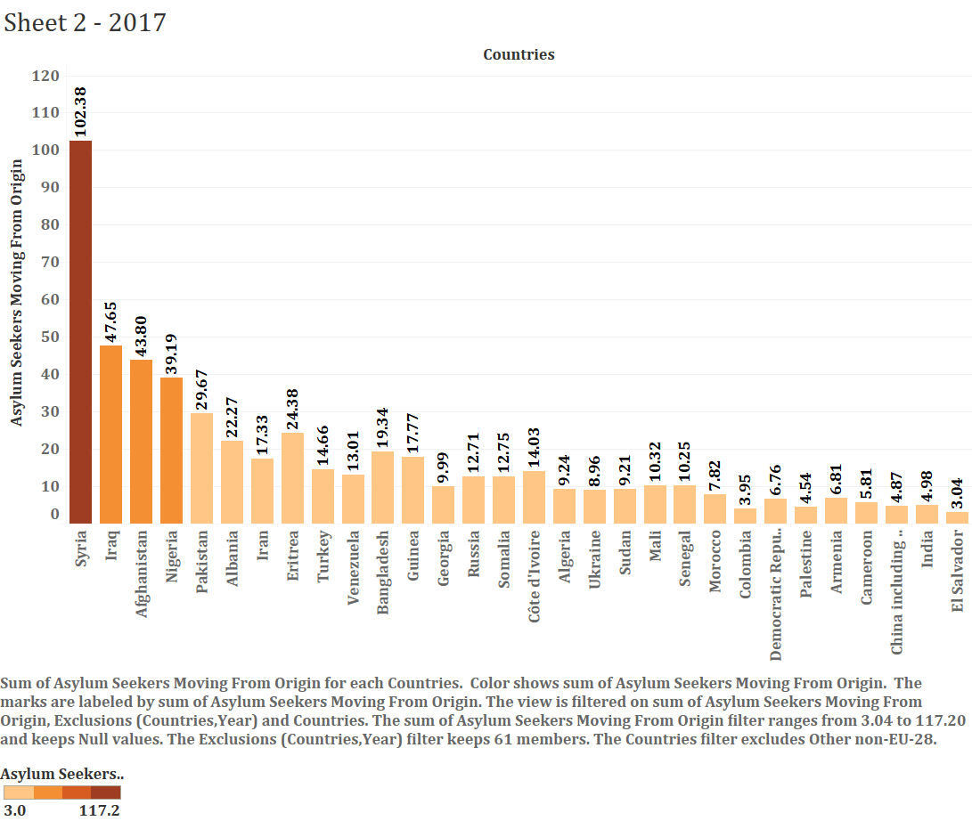

Figure 36 Volume of Asylum Seekers by Country of Origin

The above figures show the countries that have maximum asylum seekers moving to European Union Countries in year 2017 and 2018. In year 2017, Syria had maximum number of people who were seeking asylum.

Syria’s protracted civil war created an exodus that accounted for almost two-thirds of this increase between 2010 and 2015. Violence and conflict have caused millions from Syria, Afghanistan, and Iraq to leave the Middle East altogether. Many have undertaken long and often treacherous journeys to seek asylum in the high-income countries of Europe. Since the start of 2015, roughly two million asylum seekers have arrived in Europe, with five countries receiving approximately 80 percent of their applications. Processing applications has been a daunting task in and of itself, and it is likely that many people will be awaiting decisions for some time to come. Overall, the situation in Europe has tested the developed world’s commitment to global refugees; significant opposition to immigration has set in against a backdrop of slow economic growth. These tensions underscore the fact that processing applications and rehousing refugees are just the first steps in the years-long process of integration.[43]

As a result of the war in Syria, as well as other humanitarian crises, poverty, and social deprivation in Africa and elsewhere, European Union countries have experienced high inflows of asylum-seekers, refugees, and migrants.[41]

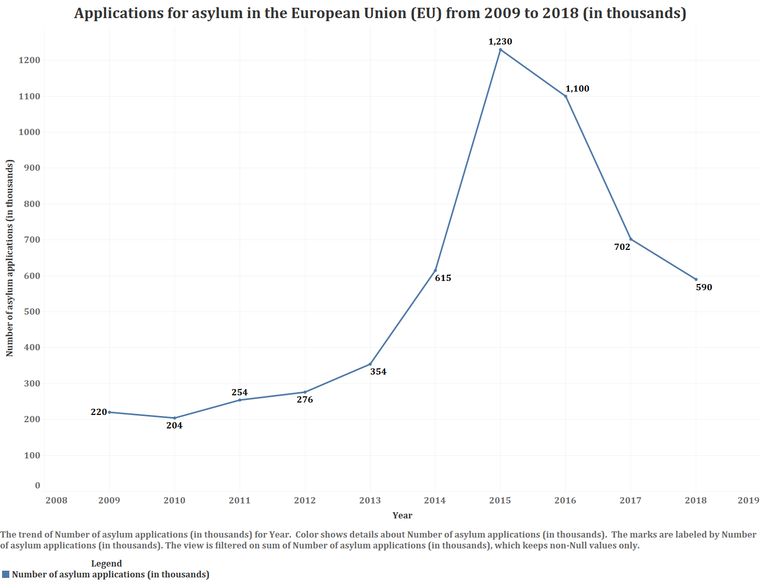

Figure 37 Applications for Asylum Seekers to EU

The EU significantly increased its funding for migration, asylum and integration policies in the wake of the increased inflow of asylum seekers in 2015. In the forthcoming negotiations on the EU’s post-2020 budget, Parliament will call for additional funding for migration. [42]

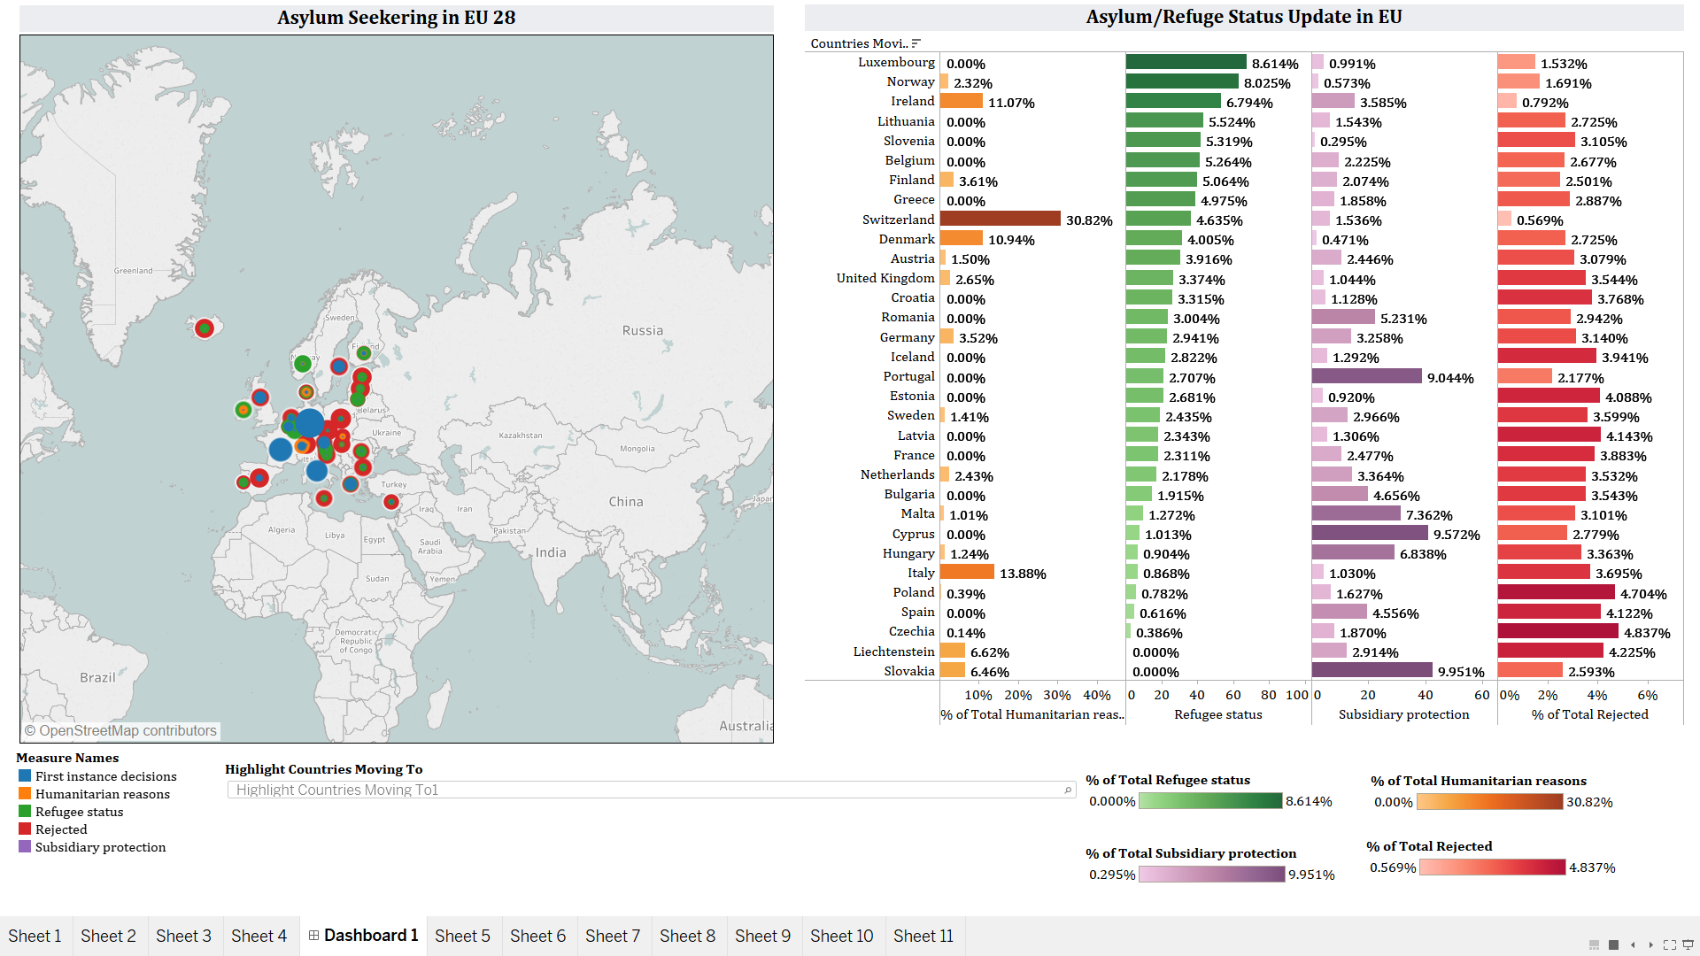

Figure 38 Asylum Seeking to EU

The figure above shows an interactive dashboard created using Tableau. The intent to create the dashboard was to understand the total number of refuges/asylum seekers allowed based on various reasons such as: Subsidiary Protection, Humanitarian Reason or Refuge Status and also number of people who were rejected asylum or entry to European Union countries.

Interestingly we see here is that Luxembourg has granted refugee status to maximum number of people looking to refuge. Other countries that provided the greatest number of refugee status are Norway, Ireland and Lithuania.

Our initial hypothesis included that countries with medium GDP or very low GDP rejected maximum application because they feared that having refugees will harm their GDP. On contrary, economists suggest that having migration benefits the host countries.

More than 90 percent of the world’s 247 million cross-border migrants moved voluntarily, usually for economic reasons. The remaining 10 percent are refugees and asylum seekers who have fled to another country to escape conflict and persecution. Roughly half of these 24 million refugees and asylum seekers are in the Middle East and North Africa, reflecting the dominant pattern of flight to a neighboring country. But the recent surge of arrivals in Europe focused the developed world’s attention on this issue. | McKinsey.com, GLOBAL MIGRATION’S IMPACT AND OPPORTUNITY

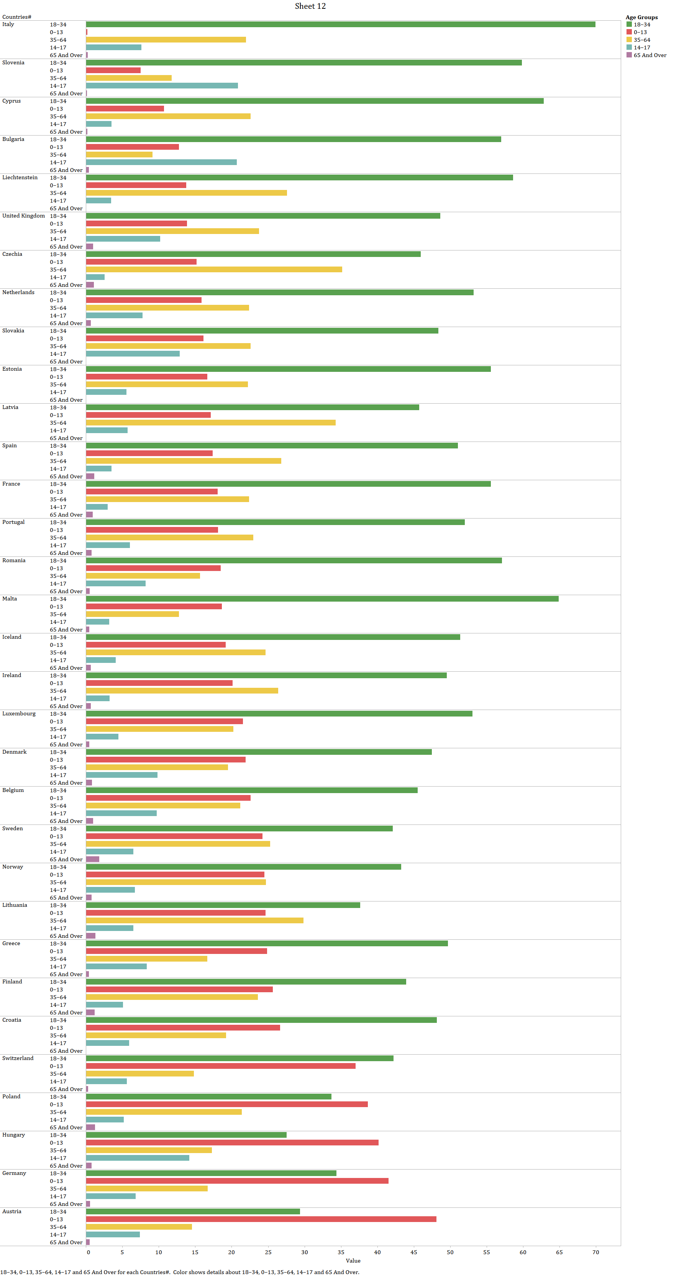

Figure 39 Age Groups of Asylum Seekers

The above visualization describes how certain age group is fleeing their origin countries and not so surprisingly, the age group with maximum number of asylum seekers.

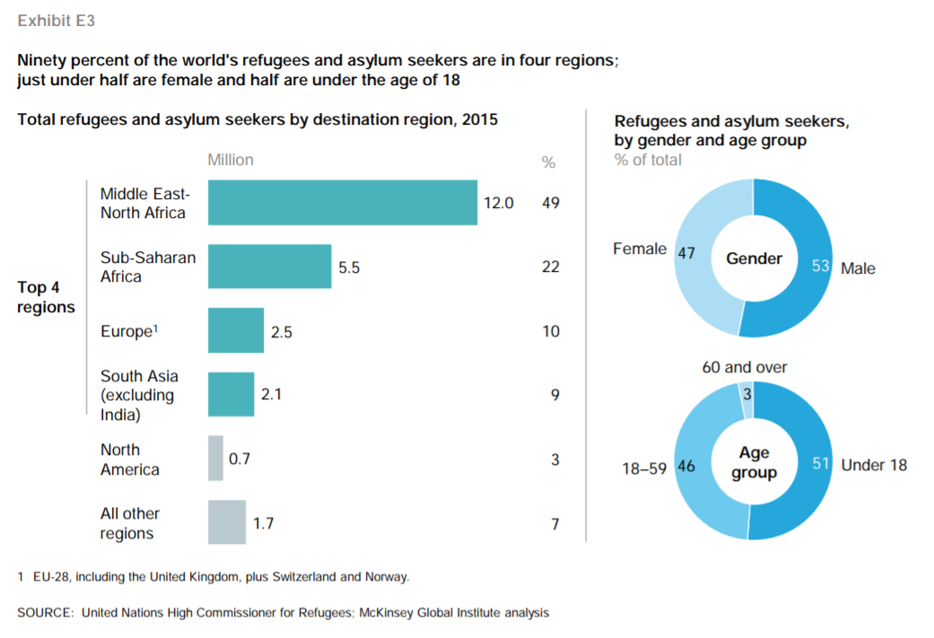

Figure 40 Asylum Seekers and Refugees by Region

### 3.2.3 Environmental Factors

H4: What are the primary environmental factors and what are the environmental outcomes?

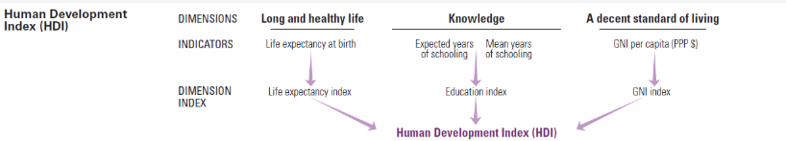

Figure 41 Human Development Reports – HDI (40)

(<http://hdr.undp.org/en/content/human-development-index-hdi>)

The United Nations (UN) tracks mortality rates among all countries from different causes. The evaluation of HDI was chosen because of its direct linkage to economic and social factors leading to migration. Additionally, the UN does study HDI against several environmental factors including *Unsafe Water, Sanitation and Hygiene Services* and *Homelessness (Displacement) Due to Natural Disasters.*

One of these causes is *Unsafe water, Sanitation and Hygiene services*. Since this cause can easily be linked to the environment, it is interesting to research what impact it can have on the population of different countries. When grouping all countries worldwide by their HDI rank and grouping mortality rates, the relationship between the two can be visualized by means of a Sankey diagram. Although figure 33 looks atypical for a Sankey diagram, it does tell a very clear story. There are almost no arches to be found, but instead there are many one to one relationship here. This tells us that countries with a high HDI have a (very) low mortality rate for this cause, whereas countries with a low HDI have a (very) high mortality rate for this cause.

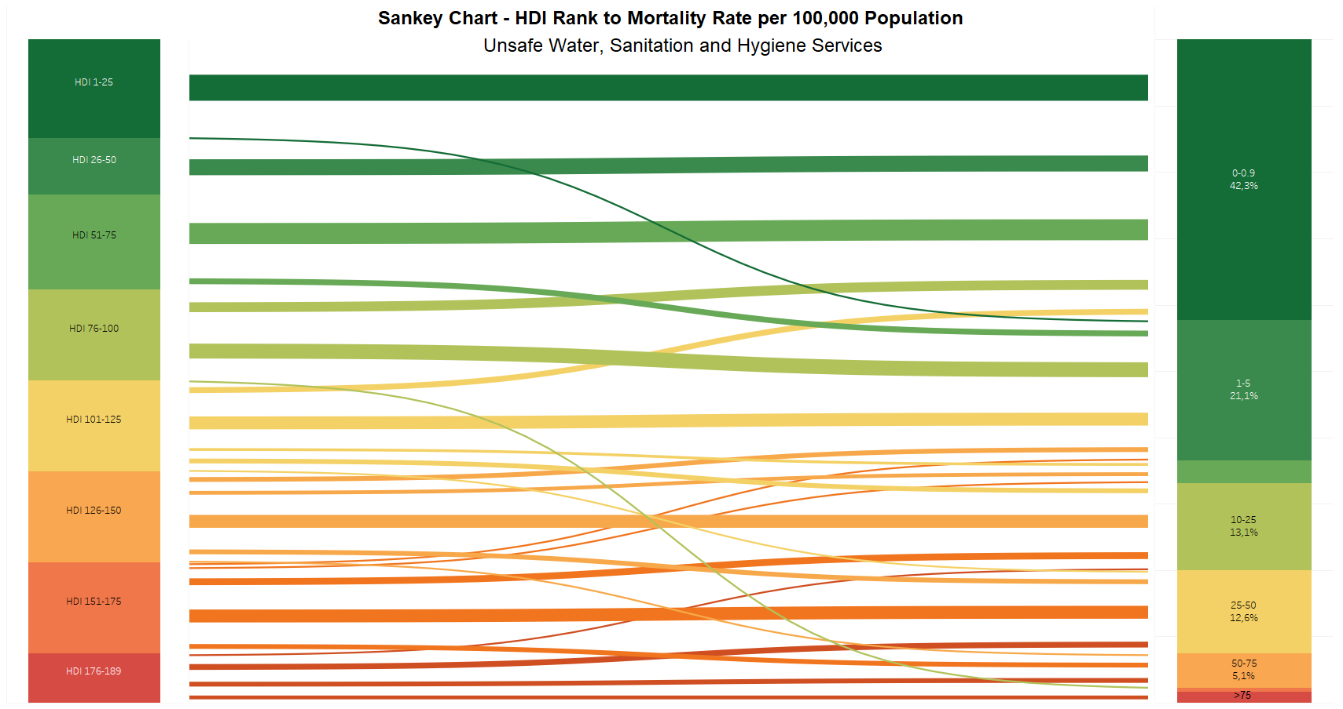

Figure 42 HDI Rank to Mortality Rate

Another environmental aspect is H*omelessness (or displacement) due to natural disasters*. It is hypothesized that countries with a higher HDI show less homelessness, as they have more financial resources to rebuild housing after a natural disaster. On the other hand, countries with a lower HDI and the people living in these countries have less financial resources to rebuild housing after a natural disaster takes place, which is why it is hypothesized that these countries show more homelessness. However, as the data of the United Nations in figure 34 shows, this hypothesis is only partly true. The countries with HDI rank 1-25 by far have the lowest homelessness due to natural disasters. Countries with HDI rank 26-100 show more homelessness than the majority of countries with an HDI rank lower than 100.

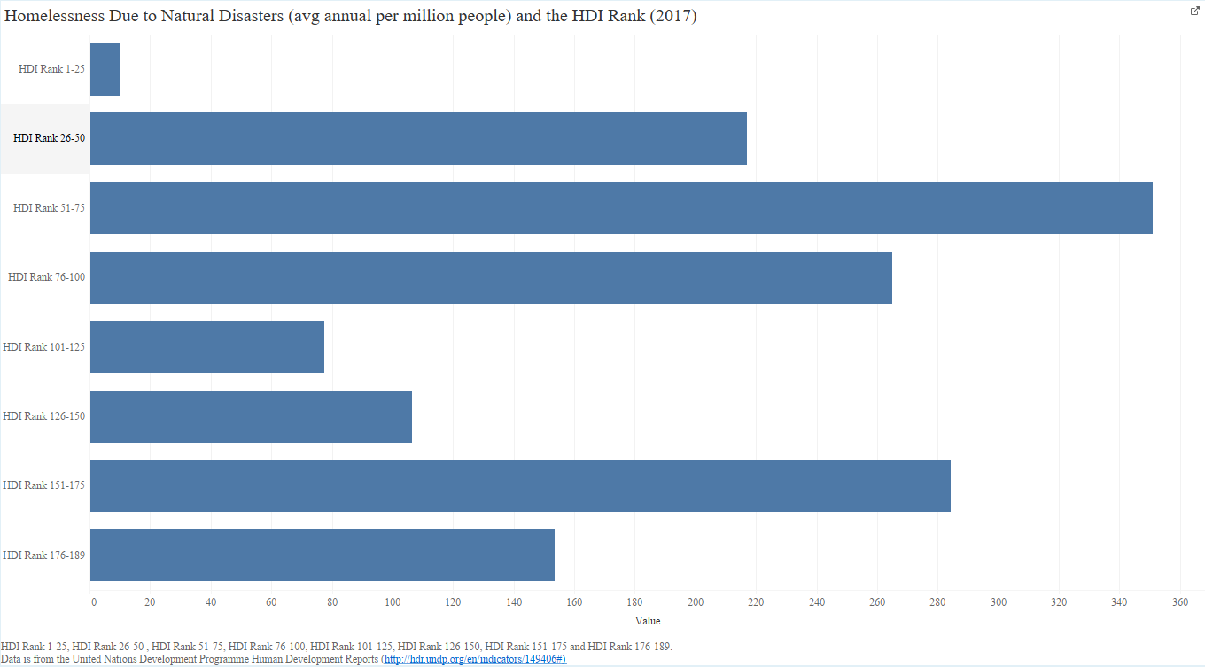

Figure 43 Homelessness Due to Nature Disasters Per Million People Per HDI (2017)

This is surprising, since the countries with a higher HDI rank are expected to have more means to rebuild housing. Interestingly, a most of the countries in HDI rank 101-150 are located close to the equator. Several of these countries have significant deserts so are less impacted by change in the storms that cause displacement while a few are coastal countries and others are island countries. These countries are Suriname, Botswana, Maldives, Dominica, Samoa, Uzbekistan, Belize, Marshall Islands, Libya, Turkmenistan, Paraguay, Gabon, Moldova (Republic of), South Africa, Philippines, Egypt, Indonesia, Viet Nam, Bolivia (Plurinational State of), Palestine, State of, Iraq, El Salvador, Kyrgyzstan, Morocco, Nicaragua, Cabo Verde. These findings may hint at the infrastructure plays a role when rebuilding housing. In addition, it is possible that the countries with the lowest HDI ranks receive more aid from wealthier countries, which allows them to rebuild housing faster and thus reducing homelessness.

### 3.2.4 Independent Factors

H5: What are the independent variables and how do they affect the decision to migrate (cost, policy, and migrant status)?

Few datasets are available that study the impact of policy, cost and migrant status on migration. One study by Helbling and Kalkum (2017) used a dataset from the Immigration Policies in Comparision (IMPIC) project to investigate immigration policies (and their effectiveness). Their dataset included immigration policies on 33 Organization for Economic Co-operation and Development (OECD) countries from 1980-2010. It included information on labor migration (economic reasons), family reunification (social reasons), asylum/refugee (humanitarian reasons) and cultural reasons [37]. The following visualization from their research shows the development of migration policies being between 0 (liberal) and 1 (restrictive). Dashed lines are EU member countries and continuous lines are other OECD countries [37].

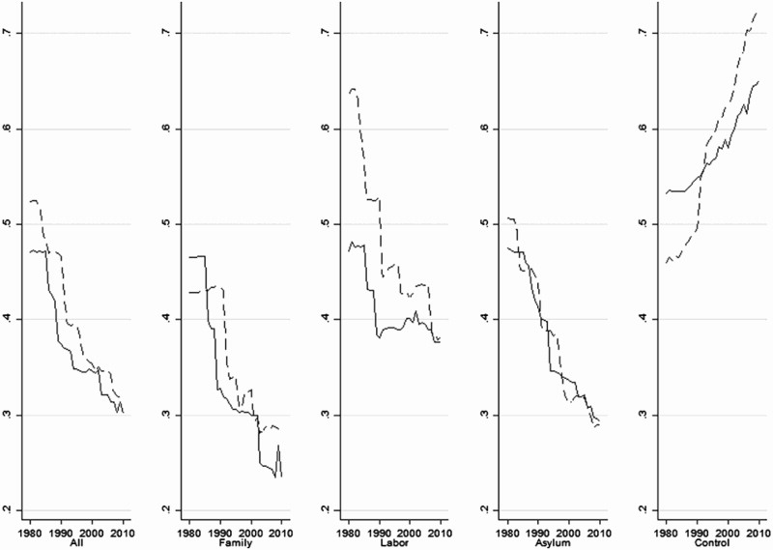

Figure 44 Helbling and Kalkum (2017) study on Liberal and Restrictive Policy and Immigration

Ultimately, the findings by Helbling and Kalkum (2017) found that as states became more generous (liberal) they became to exercise more control over who can migrate or stay in within their territory. Additionally, they found that restrictive control mechanisms were put into place to monitor if policies were followed and prevent illegal migration [37].

For the focus of this research paper, in order to test this hypothesis, a comprehensive data set such as the dataset used in this paper would be used to look for impact from policy and migrant status.

# 4. Discussion

The focus of this research is on one of the most current global trends: the migration of large numbers of people. Since migration affects not only the immigrants, but also the population of countries that accept immigrants. The analyzed factors that lead to migration, as well as the outcomes and consequences of migration. These included economic, social and environmental factors and the outcomes are economic security, social and political security and environmental security.

## 4.1 Findings/recommendations

In this paper, many aspects of immigration and different parts in the world have been analyzed. The focus has specifically been on countries that take a large portion of immigrants, namely the United States and Germany. Worldwide, the United States has the largest volume of migrant stock, although the number of asylum seekers and refugees in the United States has decreased from 2017 onwards. In Europe, Germany accepts (by far) the largest number of immigrants. However, it should be noted that Germany is also the European country with the largest population. Other European countries with smaller populations in fact accept more immigrants per 1,000 people, such as Malta, Luxembourg and Iceland. In terms of economic factors, laborers and GDP growth appeared to be the most important to explain reasons for migration. Finally, environmental factors such as water and sanitation showed how countries with a higher HDI rank perform much better than countries with a lower HDI rank, as expected. Unexpectedly, the results were very different when looking at homelessness due to natural disasters. Here, countries with a lower HDI rank did not necessarily perform worse than countries with a higher HDI rank.

## 4.2 Data gaps

Gaps in data include the valid studies on illegal immigration (in both the U.S. and Europe) in volume and country of origin. There also gaps in data for policy effectiveness and costs associated to immigration.

## 4.3 Future research

Areas of future research include the psychological and social behaviors associated to immigration. From the immigrant’s perspective, an area to research is that decision-making process, perceived perception and cultural assimilation. From the destination country perspective, more studies on the impact of immigration, programs that foster cultural independence and assimilation are necessary to provide recommendations towards policy changes. Immigration is a natural response to economic, social and environmental change but the lack of understanding how to integrate immigrants into countries remains a challenge and a topic of heated debate around the world.

The topic of immigration and how it impacts economy has been a subject of debate for a long time, all around the world. Despite the fact that this research paper supports the hypothesis of a positive economic impact by immigration, it is important to understand that the research only accounts for the Gross Domestic Product (GDP). GDP, alone itself is not a sufficient measure of economic progress. There are many other factors that need to be taken into account to paint a more vivid picture of how well a country’s economy is doing, such as the Gross National Income (GNI), Net National Income (NNI), Inflation, Debt-to-income Ratio etc. One can argue, that the GDP of a country is bound to rise when there is an increase in population but that doesn’t necessarily mean that the basic standard of living or the economic quality of life, of that country’s citizens, increases with it. Combining GDP with other economic indicators, such as the aforementioned examples, might yield different results. There is already a lot of study done and research continues regarding the true and long-lasting impact of immigration on the economic growth of a country.

With environmental factors, evaluating Human Development Index (HDI) and environmental change is valuable. Few studies exist showing the impact of agriculture on international migration, it is known that when resources (including food and water) are finite, political conflict does arise and forced migration is a result. However, do individuals migrate internationally now because they are unable to access food or water? Or are there other environmental factors driving decisions to migrate? Or does a stronger connection exist between illegal immigration and agricultural resources exist?

Another area of future research is the impact of religion and culture. Do individuals of a certain religion or ethnicity migrate to specific destinations of similar culture? Or do they migrate based on the best future opportunities?

## 4.4 Conclusion

In conclusion, immigration is a multi-faceted and complex phenomenon that includes many different factors and aspects. As such, it is difficult to draw conclusions, as migration depends on nearly all factors within countries across the world. Although this paper cannot provide a complete overview of all current migration, multiple interesting aspects that play a large role have been reported.

# 5. References

1. Davis, D., & Gift, T. (2014). The positive effects of the Schengen agreement on European trade. *The World Economy, 37*(11), 1541-1557.
2. Finotelli, C., & Sciortino, G. (2013). Through the gates of the fortress: European visa policies and the limits of immigration control. *Perspectives on European Politics and Society, 14*(1), 80-101.
3. Guild, E., & Bigo, D. (2017). Policing at a distance: Schengen visa policies. In Controlling Frontiers (pp. 233-263). Routledge.
4. Meuleman, B., & Reeskens, T. (2008). The relation between integration policy and majority attitudes toward immigration. An empirical test across European countries. Dag van de Sociologie, Leuven.
5. Shah, A. (2008, May 26). Immigration. Retrieved April 28, 2019, from <http://www.globalissues.org/article/537/immigration>
6. Iregui, A. M. (n.d.). Efficiency Gains from the Elimination of Global Restrictions on Labour Mobility: An Analysis using a Multiregional CGE Model. Retrieved April 28, 2019, from <https://ideas.repec.org/p/unu/wpaper/dp2003-27.html>
7. Net migration. (n.d.). Retrieved April 28, 2019, from <https://data.worldbank.org/indicator/sm.pop.netm?end=2017&start=1962&view=chart&year_high_desc=false>
8. Orszag, P. R. (2007, December). The Impact of Unauthorized Immigrants on the Budgets of State and Local Governments. Retrieved April 28, 2019, from <https://www.cbo.gov/sites/default/files/110th-congress-2007-2008/reports/12-6-immigration.pdf>
9. Pethokoukis, J. (2018, September 10). How immigration boosts American economic growth and innovation. Retrieved April 28, 2019, from <http://www.aei.org/publication/how-immigration-boosts-american-economic-growth-and-innovation/>
10. Ratha, D. (2004, October 01). Understanding the Importance of Remittances. Retrieved April 28, 2019, from <https://www.migrationpolicy.org/article/understanding-importance-remittances>
11. Amadeo, K. (2019, April 18). Immigration's Effect on the Economy and You. Retrieved April 28, 2019, from Ratha, D. (2004, October 01). Understanding the Importance of Remittances. Retrieved April 28, 2019, from <https://www.migrationpolicy.org/article/understanding-importance-remittances>
12. Britannica. (2016, July 27). Human migration. Retrieved March 12, 2019, from <https://www.britannica.com/topic/human-migration>.
13. Meyers, E. (2000). Theories of International Immigration Policy — A Comparative Analysis. *International Migration Review*, *34*(4), 1245–1282. <https://doi.org/10.1177/019791830003400407>.
14. Britannica. (2016, July 27). Human migration. Retrieved March 12, 2019, from <https://www.britannica.com/topic/human-migration>.
15. Meyers, E. (2000). Theories of International Immigration Policy — A Comparative Analysis. *International Migration Review*, *34*(4), 1245–1282. <https://doi.org/10.1177/019791830003400407>.
16. Migration Policy. (2019). Migration Policy. Retrieved March 12, 2019 from <https://www.migrationpolicy.org/topics/immigration-policy-law>.
17. White, R. (2018). *Immigration Policy and the Shaping of US Culture: Becoming America*. Edward Elgar Publishing.
18. Schuck, P. (1990). The Great Immigration Debate. Retrieved from <https://prospect.org/article/great-immigration-debate>.
19. Newland, K. (2015, July 22). Beyond Asylum: Adapting the Global Protection System to Better Meet Escalating Needs. Retrieved from <https://www.migrationpolicy.org/events/beyond-asylum-adapting-global-protection-system-better-meet-escalating-needs>.
20. Schuck, P. (1990). The Great Immigration Debate. Retrieved from <https://prospect.org/article/great-immigration-debate>.
21. Newland, K. (2015, July 22). Beyond Asylum: Adapting the Global Protection System to Better Meet Escalating Needs. Retrieved from <https://www.migrationpolicy.org/events/beyond-asylum-adapting-global-protection-system-better-meet-escalating-needs>.
22. Dooling, S. (2018, December 3). What Is Asylum? Who Is Eligible? Why Do Recent Changes Matter? Retrieved from <https://www.wbur.org/news/2018/12/03/asylum-explainer>.
23. Gleditsch, NP., Nordas, R. & Salehyan, I. (2007). Climate Change and Conflict: The Migration Link (International Peace Academy, New York).
24. Feng, S., Krueger, A. & Oppenheimer, M. (2010). Linkages among climate change, crop yields and Mexico-US cross-border migration. (PNAS). <https://www.pnas.org/content/pnas/107/32/14257.full.pdf>.
25. Byravan, S. & Chella Rajan, S. (2006). Providing new homes for climate change exiles. In *Climate Policy, 6*(2), 247-252. <https://doi.org/10.1080/14693062.2006.9685599>.
26. Rigaud, K.K., de Sherbinin, A., Jones, B., Bergmann, J., Clement, V., Ober, K., Schewe, J., Adamo, S., McCusker, B., Heuser, S., & Midgley, A. (2018). Groundswell: Preparing for Internal Climate Migration. Washington, DC, The World Bank.
27. Warner, K., & Afifi, T. (2014). Where the rain falls: Evidence from 8 countries on how vulnerable households use migration to manage the risk of rainfall variability and food insecurity. In *Climate and Development, 6*(1)1-17.
28. *Asylees, Fiscal Year 1997* (Vol. 3, Rep.). (1999).
29. USCIS. (1997). US Citizenship & Immigration Services Annual Report: Asylees, Fiscal Year 1997. Retrieved from: <http://uscis.gov/graphics/sharedlaboutus/statistics/asylee97.pdf>.
30. Geddes, A., Adger, W. N., Arnell, N. W., Black, R., & Thomas, D. S. G. (2012). Migration, Environmental Change, and the ‘Challenges of Governance.’ In *Environment and Planning C: Government and Policy*, *30*(6), 951–967. <https://doi.org/10.1068/c3006ed>.
31. Hunter, L. M., Luna, J. K., & Norton, R. M. (2015). The Environmental Dimensions of Migration. In *Annual review of sociology*, *41*, 377–397. <https://doi.org/10.1146/annurev-soc-073014-112223>.
32. Anton, D.K. (2018). Climate Migration and Security: Securitisation as a Strategy in Climate Change Politics. In *International Journal of Refugee Law, (30)*2, 403-406. <https://doi.org/10.1093/ijrl/eey029>.
33. Sagynbekova, L. (2017). Environment, rural livelihoods, and labor migration: a case study in Central Kyrgyzstan. *Mountain research and development*, *37*(4), 456-464.
34. Hunter, L. M., Luna, J. K., & Norton, R. M. (2015). The Environmental Dimensions of Migration. *Annual review of sociology*, *41*, 377–397. <https://doi.org/10.1146/annurev-soc-073014-112223>.
35. United Nations. (2017). Migrant Stock Documentation 2017. <https://www.un.org/en/development/desa/population/migration/data/estimates2/docs/MigrationStockDocumentation_2017.pdf>.
36. Domonoske, C. (2017, July 12). U.S. Refugee Admissions Pass Trump Administration Cap Of 50,000. Retrieved April 28, 2019, from <https://www.npr.org/sections/thetwo-way/2017/07/12/536899605/u-s-refugee-admissions-pass-trump-administration-cap-of-50-000>.
37. Marc Helbling & Dorina Kalkum (2018) Migration policy trends in OECD countries, Journal of European Public Policy,25:12, 1779-1797, DOI: [10.1080/13501763.2017.1361466](https://doi.org/10.1080/13501763.2017.1361466)
38. Environmental Law Institute (2019).Environmental Displacement and Migration <https://www.eli.org/migration>
39. Anthony Oliver-Smith. (2012). Debating Environmental Migration: Society, Nature and Population Displacement in Climate Change. Journal of International Development. J. Int. Dev. 24, 1058–1070 (2012) Published online in Wiley Online Library (wileyonlinelibrary.com) DOI: 10.1002/jid.2887
40. United Nations Development Programme. (2018). Human Development Index (HDI) <http://hdr.undp.org/en/content/human-development-index-hdi>.
41. Juran, Sabrina. (2017). A Profile of Germany's Refugee Populations. Population and Development Review. 43. 10.1111/padr.12042.
42. EU migrant crisis: facts and figures. (2017)<http://www.europarl.europa.eu/news/en/headlines/society/20170629STO78630/eu-migrant-crisis-facts-and-figures>
43. McKinsey Global Institute - People on the move: Global migration’s impact and opportunity, 2016.
44. Asylum and Refugee Status Determination. (2002). UNHCR Statistical Yearbook. doi:10.3897/bdj.4.e7720.figure2f